HCC / IS 636

**UMBC Counseling Center Scheduling System**

Group #1



# 

**TEAM REVOLUTION**

Shraddha Kapse

Suman Pogul

Rachael Muller

Priya Jain

Prashanthi Sandra Grace **Date of Submission:** 12/13/2022

# Abstract

# Retriever Integrated Health (RIH) supports students by assisting them with mental health, emotional, and social concerns that interfere with their academics. The main objective of this project is to propose a self-service scheduling application for students of UMBC. Currently the students of UMBC need to call the counseling center and make an appointment. Due to which they have been facing a lot of problems, some of them include limited availability of counselors or employees, prolonged waiting or procedure to make an appointment and less customer satisfaction.

Taking all this into consideration we propose a Self-Service Scheduling Application. We will use waterfall and agile methodology to develop this application in the quickest manner and further moving on not only for the students of UMBC but also we can make this application available all over the world.

The main motto of this project is to not only save many of the students from their mental health or illness but would give them a new beginning to their journey of life.

**Abstract** **2**

**Introduction** **4**

**System Request** **5**

**Project Management Plan** **20**

**Requirements Elicitation Methods** **27**

**System Proposal** **33**

**Design** **54**

**Alternatives** **65**

**Future work** **65**

**Conclusions** **66**

**References** **67**

## 

# Introduction

## **1.1 Purpose**

Retriever Integrated Health (RIH) brings together Health services including Counseling Center offices to work in a collaborative environment in order to support University of Maryland Baltimore County’s (UMBC) students with high-quality healthcare services provided by administrative staff and healthcare professionals in regard to their mental, emotional and social concerns.

This report will explain the current system for booking an appointment in the UMBC Counseling center, the problems faced with it and a new proposal.This document intends to propose and outline a development strategy for a self-service scheduling application. This document would serve as a guide for any future implementation and solutions.

## 1.2 Problems faced in Current System

The idea proposed seeks to address a few problems that have been identified in the current system as given below:

1. Availability of the employees - This becomes a major concern when the primary source of booking an appointment is via a phone call. What would happen if all the staff who book an appointment and manually enter the details are busy? What would happen if a student wanted to schedule an appointment outside of business hours?
2. Inefficient use of time - Often phone calls feel like an inefficient use of time as it makes the procedure a bit lengthy and any data captured from a phone call runs the risk of being inaccurate. Imagine this - What would happen if the information that was explained over the phone by the student while booking the appointment was mis-entered into a computer system and then had to be gathered and re-entered again.
3. Less customer satisfaction - Having to re-explain details, having to follow a confusing process, and not being able to book an appointment because of employees’ busy schedules would eventually lead to less customer satisfaction and represent a barrier to accessing care for student clients

## 1.3 Project Description

This project aims to redesign the scheduling system for the Counseling Center, a subsection of RIH at UMBC. The current system for students to make appointments with counselors requires students to call a phone line during business hours and speak to a staff member directly to make an appointment. The staff member then enters the student’s information manually, sets the appointment time, and verbally instructs the student to fill out specific paperwork before the appointment. The current system is rife with inefficiencies, opportunities for user error, and does not adequately serve the needs of UMBC’s diverse student population. We propose to replace the existing scheduling system with an integrated, self service scheduling application. We feel this system would resolve inefficiencies, reduce the potential for human error, and better serve the needs of UMBC students.

# System Request

## 2.1 Project Sponsor

This proposal deals with a system that is currently in use by a trusted company. It is clear that the RIH team was not involved in creating this system concept because it was a class assignment (although they did provide supporting information). But typically, a senior stakeholder at RIH or the Counseling Center would serve as the project sponsor for a system of this kind. Counseling is one of four disciplines integrated into the general organizational structure of RIH, which is led by Dr. Bruce Herman (see Figure 1 below).

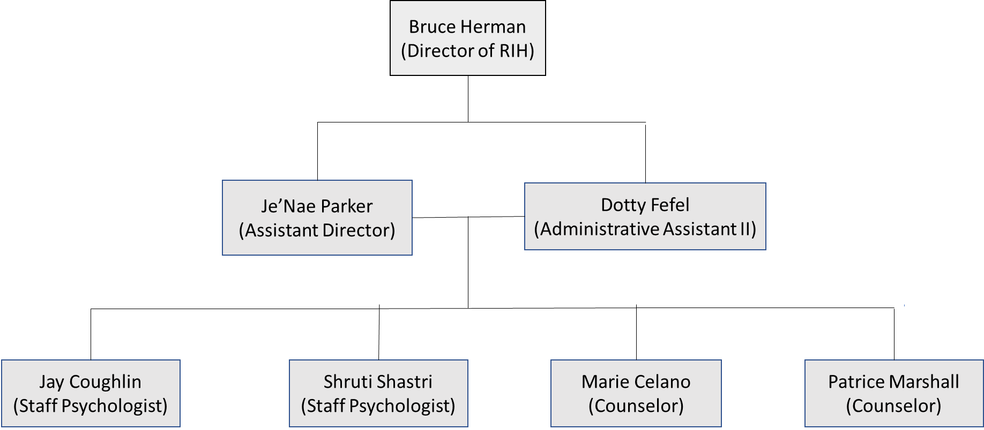

*Figure 1: Organizational Chart*

We believe a senior leader in the "Administrative" area would be the most likely to support this idea for its intended use. The "Administrative" team takes care of all of RIH's logistical and administrative requirements, including scheduling doctor appointments and placing supply orders. These employees would be the ones most likely to notice the vast differences between the way appointments are processed through the various web portals for other appointments and the Counseling Center. We believe this would be a primary motivating factor driving this project ahead because the inefficiencies of navigating numerous complex scheduling systems prone to human mistake would likely be most obvious to someone who worked directly with those systems.

The Director of RIH, Dr. Bruce Herman (mentioned above), who then connected us with the Assistant Director of Administration, Je'Nae Parker, were the two specific staff individuals to whom our team was sent when we initially contacted out with requests for information . We think Je'Nae Parker would be our main project sponsor for the purposes of this proposal.

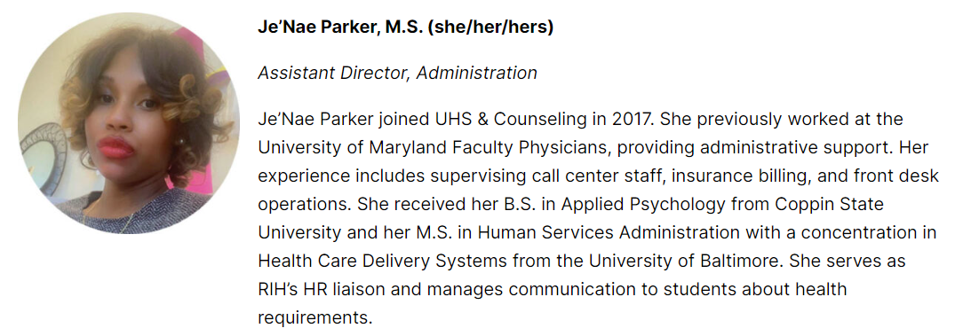

## 2.2 Business Need

This proposal meets many business needs. This system would help the UMBC Counseling Center satisfy student clients' mental health needs and connect them to university and off-campus resources, improving client satisfaction. The proposed approach would improve scheduling and reduce errors. The proposed system may reduce no-shows.

In a post-covid era, college students are facing more mental health issues. Penn State's Center for Collegiate Mental Health studied changes in average psychological distress from Fall 2017 (pre-COVID) to Fall 202 from 243,694 students seeking treatment from 85 collegiate counseling services. "Although numerous categories of stress increased at least somewhat in Fall 2021 compared to pre-COVID levels, the spike in Academic Distress, Social Anxiety, Family Distress, Eating Concerns, and past experiences of trauma and sexual assaults were particularly striking," they found. These findings underscore the need for colleges and institutions to be proactive in assisting students' mental health needs as they cope with higher distress and adapt to life during difficult times. (CCMH 2021).

After the COVID-19 outbreak, the UMBC Counseling Center must boost access to students and improve student-resource relationships. The planned self-service application would help students book appointments at convenient times. If the Counseling Center cannot satisfy their requirements, an app could connect students to on- and off-campus options. An app might also simplify the scheduling and intake process, making it easier for students who struggle with motivation and focus to access. The proposed scheduling method would speed up and simplify scheduling. The student client might enter their data and choose from available hours, counselors, and specialties to discover what services are accessible without talking. Putting data themselves reduces the likelihood of errors or miscommunications.

Finally, RIH staff noted that students must submit paperwork before their first appointment. Since scheduling is done over the phone, students must obtain the paperwork, print and complete it, and bring it to their first visit. Without this papers, pupils are marked as "no-shows" and cannot get treatment services, wasting valuable resources. This self-service software would easily integrate documents, avoiding students from forgetting it. No-shows would disappear (for paperwork reasons). Push notifications on smartphones could reduce no-shows for this app. Integrated reminders may improve appointment attendance and save waste. In conclusion, the self-service scheduling tool would help the institution meet rising student mental health support needs, broaden student client scheduling access, reduce human error, improve process clarity and efficiency, raise process compliance, and drastically reduce wasted resources.

## 2.3 Business Requirements:

**2.3.1 Methods**

Developing requirements for a redesign of an existing system, especially one that handles private medical information, was difficult, so we took different approaches. We started with RIH forms. To illustrate best practices, we compared similar scheduling apps (ZocDoc, for instance). Next, we contacted RIH staff to get further details and possibly an interview. The email conversation accidentally answered some of our interview questions, making it valuable even if an interview was not possible before this proposal. Finally, we surveyed UMBC students using Google forms to learn their preferences . We asked about hypothetical Counseling Center system knowledge and preferences to protect privacy. To encourage answers, we offered students a $15 Starbucks gift card for entering their email address. The poll revealed the UMBC Counseling Center's biggest issues and guided the below standards. 75% of respondents said they didn't comprehend UMBC Counseling Center services (Figure 2).

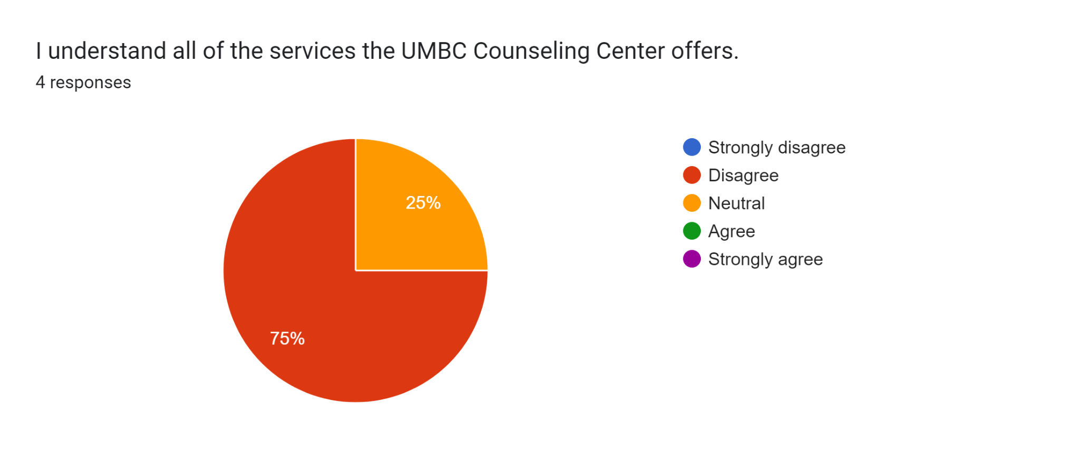

*Figure 2*

No respondents were satisfied with the UMBC Counseling Center scheduling method, and 50% strongly disagreed (Figure 3).

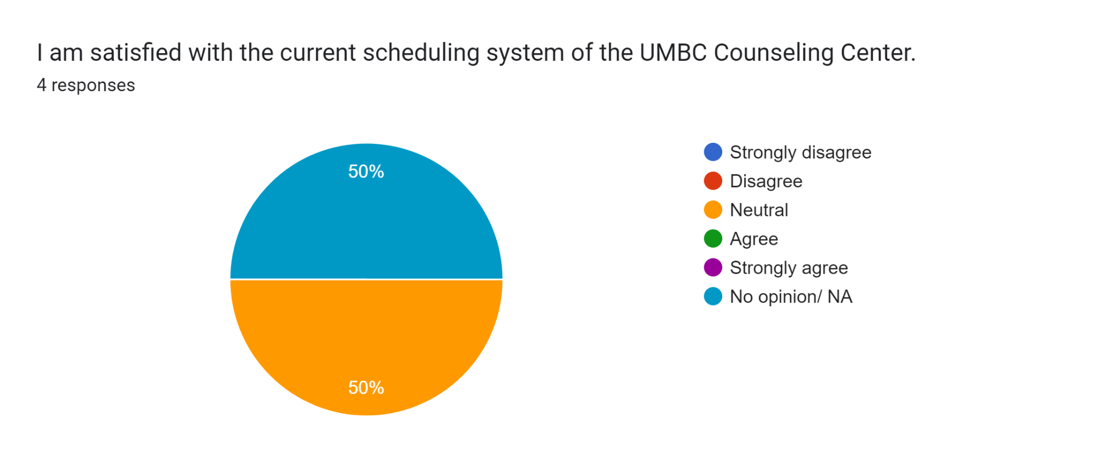

*Figure 3*

"Web browser" scored as high as "talking to a person on a phone" (75%) and slightly higher than "mobile app" (50%), indicating that several platforms must be supported (see Figure 4).

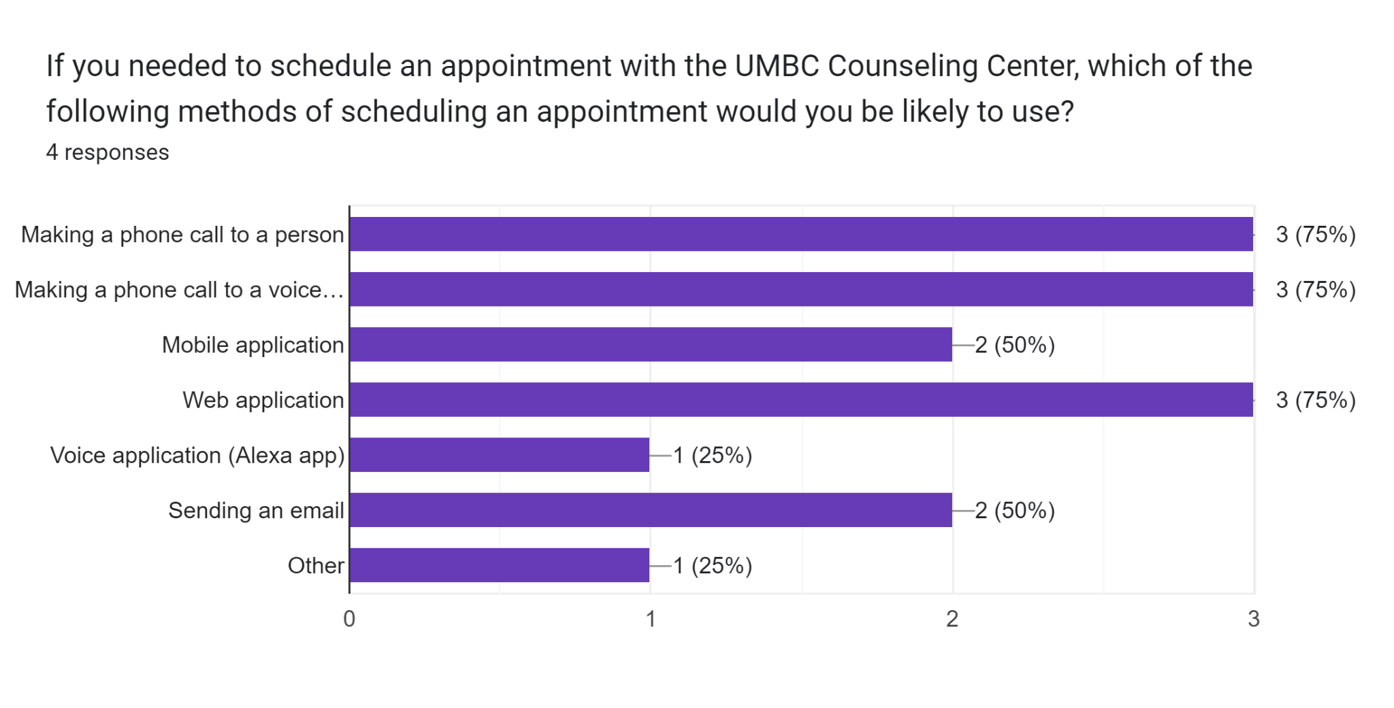

*Figure 4*

Finally, poll results showed that most of our recommended features were significant to most respondents, with some surprising results. Over 50% of respondents ranked these features "very important".

* System should allow me to make an appointment outside of normal business hours
* System should allow me to speak with a human
* System should be accessible to students of varying physical abilities
* System should help me understand what services UMBC offers
* System should help me to understand what steps are required to attend an appointment at the counseling center
* System should be easy to comprehend with secure access
* System should connect me to additional mental health and wellbeing resources, both on and off campus
* System should generate a reminder prior to the appointment

While students were dissatisfied with the current scheduling system, 100% of respondents said a system should allow them to interact with a human, indicating that they wanted to keep that capability while adding more options.

**2.3.2 Requirements**

**Functional Requirements**

* The system must allow students to create a profile
* The system must allow students to enter essential information into their profile
* The system must allow for students to sign disclosures with an e-signature
* The system must allow students access at any time of day
* The system must support e-reader functionality and provide accessibility support for students with physical disabilities
* The system must allow students to filter available counselor time slots by preferences
* The system must allow students to view available counselor time slots and select a date and time that works for them
* The system must communicate to the student in an email that their appointment request has been sent and is pending verification by a staff member
* The system must communicate to the student in an email when their appointment request has been verified by a staff member
* The system must allow the student to export the information to their personal calendar
* The system must allow the student to opt-in to push notifications reminding them of an upcoming appointment
* The system must provide the student with links and recommendations for additional resources both on and off campus
* The system must provide the student with a phone number, physical address, and email address to reach out to the Counseling Center directly for help

**Non Functional Requirements**

* The system will integrate with existing calendar management and scheduling systems
* The system will run as a web application accessible via desktop and mobile devices
* Personal information is protected in compliance with HIPAA
* Only authorized UMBC staff members can see students’ personal information
* The system supports up to 280 students using the application simultaneously
* The system updates calendar availability every 1 second
* The system is compatible with any web browser

## 2.4 Business Value

This proposal proposes to redesign the UMBC Counseling Center Scheduling service to increase efficiency, reduce cost per client, provide access to more students, and improve care. Counseling centers are expensive. Addressing these issues can save university expenditures while improving service. Counselors often make appointment calls. Counselors must have advanced degrees and certificates, unlike administrative staff. An administrative assistant cannot legally provide the same services as a psychologist, but a psychologist may. Licensed psychologists earned $81,040 in 2021, while administrative assistants and secretaries earned $39,680. (US. Bureau of Labor Statistics 2022). Thus, the time counselors spend booking appointments and manually inputting data instead of offering specialized counseling services to students costs the institution money by paying for work that could be done cheaper. Every hour a counselor spends answering student calls and doing administrative work is an hour inaccessible to a student seeking counseling. These services overlap inefficiently. User mistakes affect. A human manually entering data into a system can transpose a letter of an email or phone number. Users entering foreign data are more prone to make mistakes than those entering their own.

Finally, counseling center employees (see further supporting materials) noted that one of the biggest problems with the current system is that students who scheduled initial sessions were separately provided papers to fill out and bring to their first appointment. Unfortunately, many students did not bring their papers to this initial meeting, preventing the counselors from providing therapeutic services and marking the client as a no-show. No-show appointments waste time and prevent counselors from seeing other students. This system change would greatly reduce no-show appointments. However, changing the counseling center scheduling method cuts university costs. It also improves student care and supports the counseling center's mental health purpose. The counseling center's services and clients make seemingly minor access concerns a serious obstacle to therapy. Students can only get care during business hours when a counselor is available to schedule an appointment. The student cannot schedule if nobody is available. The student must also contact, find the paperwork for an initial appointment, fill it out, and bring it with them.

The system is quite complicated. Usability flaws that can be annoying elsewhere can delay service and undermine the Counseling Center's objective of student mental health support. Before calling the system, clients must browse a maze of webpages. This system makes students who need aid frustrated and discourages them from booking an appointment. Figure 5 shows that a user requesting a counseling center appointment should click the "Counseling Center" tab under the dropdown menu on the Retriever Integrated Health (RIH) site. The dropdown does not allow appointment scheduling. A drop-down tab labeled "Appointments" doesn't provide appointment scheduling information either.

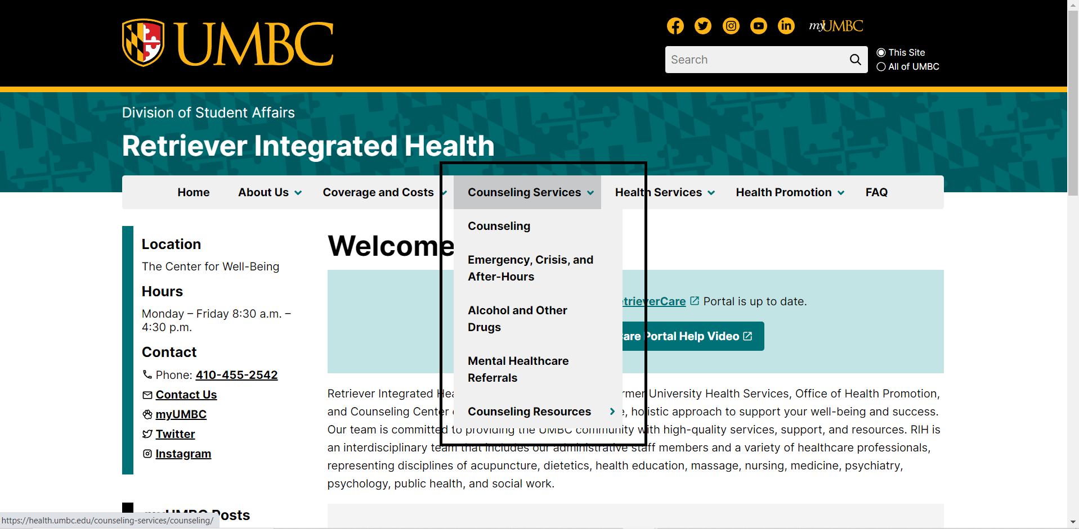

*Figure 5*

Instead, the student must click a link on the web page to access the my Retriever Care portal, which requires a UMBC login. The user must infer that the my Retriever Care site allows users to schedule appointments, let alone counseling center appointments. After logging in with myUMBC credentials, users will be prompted to create an account or enter a birthdate to verify their identity (see Figure 6).

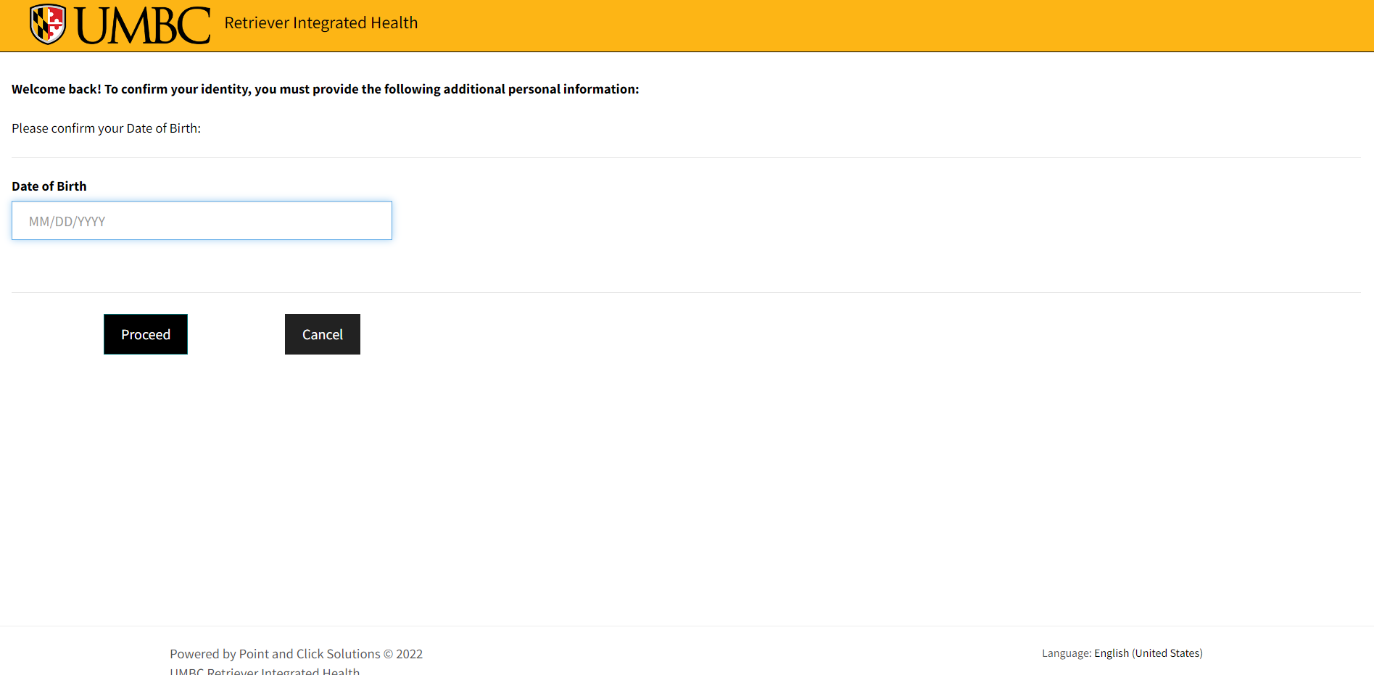

*Figure 6*

After creating or confirming their account, students are taken to a page with six clickable buttons. The bottom of the page has the appointment button (see Figure 7).

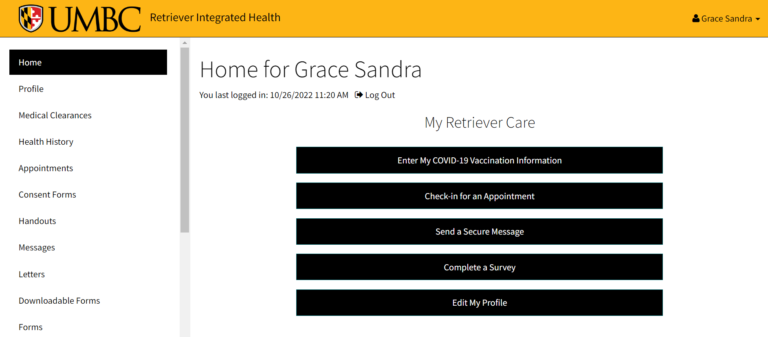

*Figure 7*

But once the student clicks through to schedule an appointment, they are then directed to a screen which instructs them to call for an appointment (see Figure 8). No phone number is provided, which then necessitates the student presumably searching for the Counseling Center’s number separately and then placing a phone call.

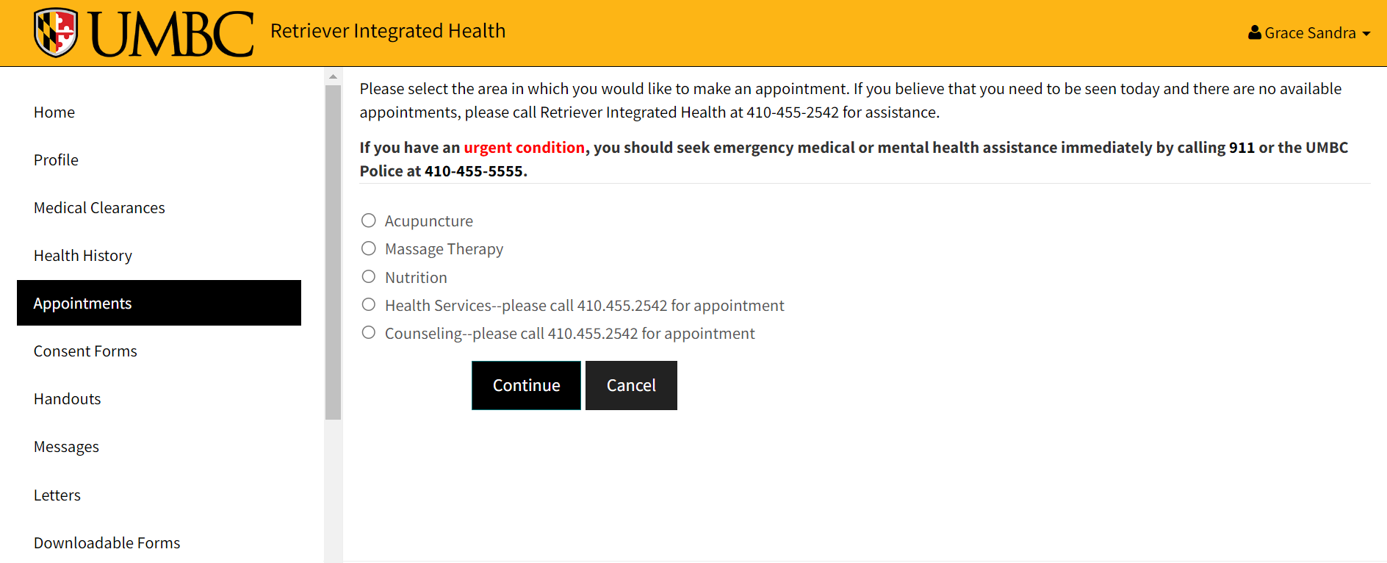

*Figure 8*

And even if the Student clicks on the option given in figure 4. It then goes to the page shown below (Figure 5) which prompts that the previous page has requested an unrecognized branching destination. Even though the option to book an appointment is given in the retriever care website, it leads to nowhere which is not the case for other services provided (refer Figure 9, 10 & 11 for comparison).

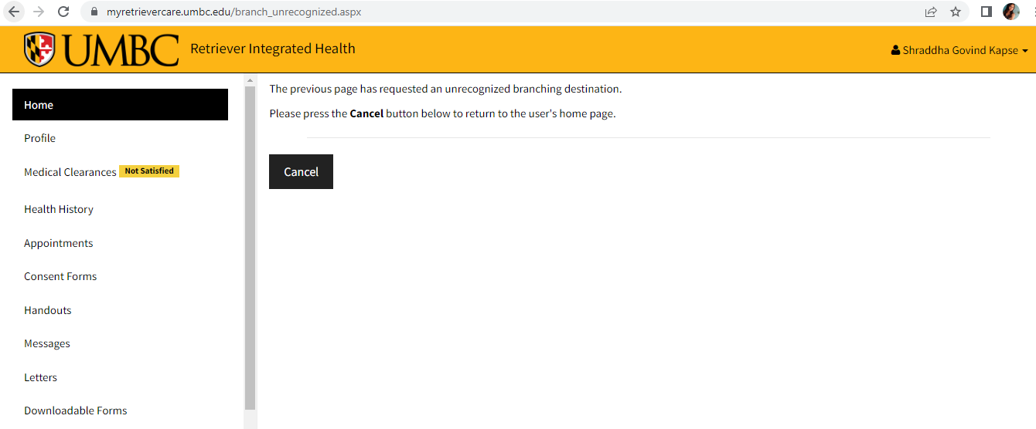

*Figure 9*



*Figure 10*

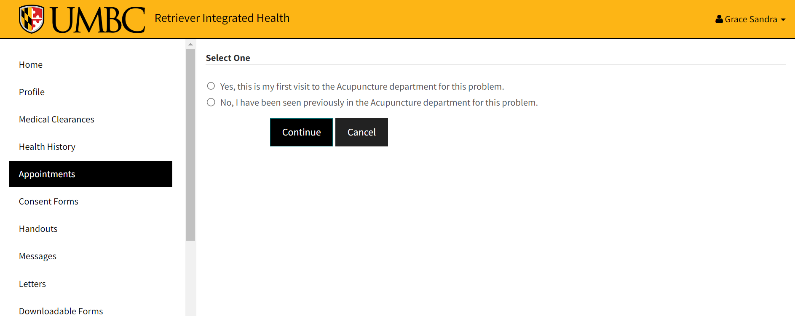

*Figure 11*

All of the above steps represent a major barrier for students to even understand what steps they need to take to access the services of the Counseling Center.

Students in need of mental health services suffer usability and time inefficiencies. In a 2022 review of barriers and facilitators for NHS doctors accessing mental healthcare, researchers found that difficult processes, lack of understanding of services, lack of accessibility, restricted time, and wasted time were important impediments (Zaman et al. 2022). In a 2010 study on anxiety disorder treatment hurdles, 63.2% of respondents mentioned "not knowing where to go to receive help" (Chartier-Otis et al. 2010). These findings support the premise that mental healthcare should be easy to access and efficient. As a mission-driven nonprofit organization, the UMBC Counseling Center can add value by providing student mental health support in a more cost-effective way. Our proposal increases corporate value by lowering mistakes, expense, and access.

## 2.5 Special Issues

HIPAA protects patient data. The HHS states that the HIPAA Privacy Rule protects patient information, and the Security Rule protects electronic health information (De Groot 2022). HIPAA Security and Privacy Rule compliance is likely for any UMBC Counseling Center app due to the data collected. The Security Rule requires constant risk assessments, administrative, physical, and technical precautions, and more (McKeon 2022).

HIPAA compliance is required for any counseling center implementation because the present system handles sensitive data. Thus, while a new system with new capabilities may require new protections, Retriever Integrated Health (RIH) may already have part of the institutional expertise and administrative infrastructure to meet these needs.

## 2.7 Feasibility Analysis

A feasibility study is a detailed analysis that considers all of the critical aspects of a proposed project in order to determine the likelihood of it succeeding. The feasibility analysis includes a discussion of the following sections:

**2.7.1 Technical Feasibility**

Before constructing a system, we should evaluate performance and answer questions like whether any beneficial technology is available. If compatible, will it work in the current environment? After selecting the technology, technical knowledge is needed to develop the system. All procedures require an online consultation application professional. Student data handling appears to be a major issue. Most objects can be added to the database for appointments. Because its components are readily available, the system is technically feasible. The database stores lots of data. The system produces reliable reports.

**2.7.2 Economic Feasibility**

The project team will win stakeholder trust by analyzing the system's pros and cons to determine if it's worth developing the app. Identifying project dangers helps the team create preventive solutions. It facilitates pre-implementation system evaluation. Because the project includes front-end and back-end development, up to five highly skilled developers may work on it. $25000 covers construction. Operating expenditures are daily expenses. Labor, electricity, and database upkeep are included. Operation costs $10000. $15000 for database, servers, and software. Hiring designers and designing might cost $10,000.

| **Project elements** | **Cost** |
| --- | --- |
| Software and Database expenses. | $15000 |
| Operational cost | $10000 |
| Development cost | $25000 |
| Design cost | $10000 |
| Total Costs | $60000 |

**2.7.3 Organizational Feasibility**

The counseling app streamlines RIH appointment scheduling and contact. The programme addresses issues including phone appointment personnel availability. What if the student wants an after-hours appointment? Calls prolong the process, making them inefficient. Re-explaining, following a lengthy process, and being unable to set an appointment due to staff' busy schedules decrease customer satisfaction. Organizational viability can assess if a proposed system has the management experts, managerial know-how, and resources needed to succeed. It also informs consumers whether the proposed system will suit all needs. This application involves students. The existing system is inefficient, prone to catch techniques, and time-consuming. The proposed application fixes the system's inefficiencies. The following factors determine the application's operational viability:

1. Information: This system supports database management by providing fast updates and reliable information to its users, staff, and management.
2. Efficiency: The system for database management utilizes its resources and time effectively.
3. It has been determined that the proposed approach is more practical than the current system after taking into account all of the variables factors. End users will find it easier to issue and inform other users about the project's goals, and management will spend less time trying to interpret the data.

# Project Management Plan

This section gives us a detailed view of the tasks which need to be done at each stage. The primary model is to develop a self-scheduling application for students of UMBC. The main focus of this project will be to make this application user friendly so that is feasible to be used by students. Preliminary model of this application would include scheduling an appointment with the UMBC counselor and storing the data of the user securely in the database so that it would be helpful for the counselor to look into it anytime and provide necessary guidance/help as needed by the student.

**Estimated Schedule**

## 3.1 Initial Plan

The initial plan was created based on the feasibility analysis report but as we move further into the project the plan has been changed due to quick achievements of the tasks in the plan.

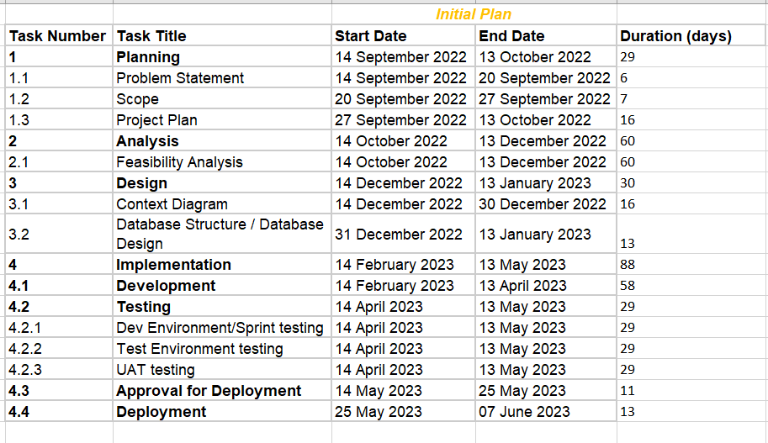

## 3.2 Final Plan

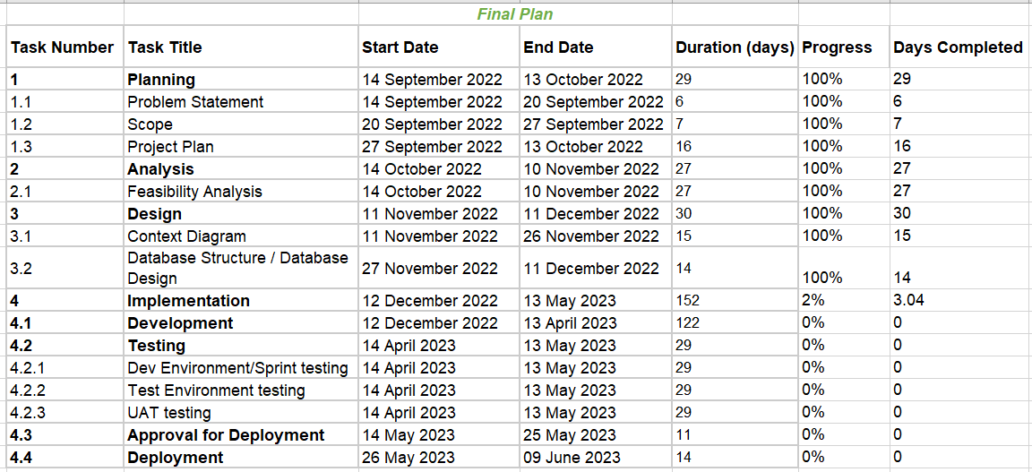

The final plan has been updated and new estimated timelines have been frozen. The major difference between the initial plan and final plan was in the Analysis and Design phase. After completing the planning phase and while in between of the analysis phase we encountered that the timeline of both analysis and design can be reduced by half.

In the above plan the planning phase starts from 14th September 2022 and ends on 13th October 2022 giving it a total duration of approximately a month. The analysis and design phase which involves both technical and business aspects would last for about a month respectively.  
The development phase is the long lasting one which would take a lot of efforts and staff to achieve it and probably lasts up to 4 months. After the development phase the testing of the application begins and parallel testing and development tasks are repeated until the testing phase is completed. After rigorous testing we need to take the approval from client for application deployment into the and application should be handed over to the maintenance team then after to have a close follow up with the issues and errors encountered post deployment.

## 3.3 Gantt Chart (Final Plan)

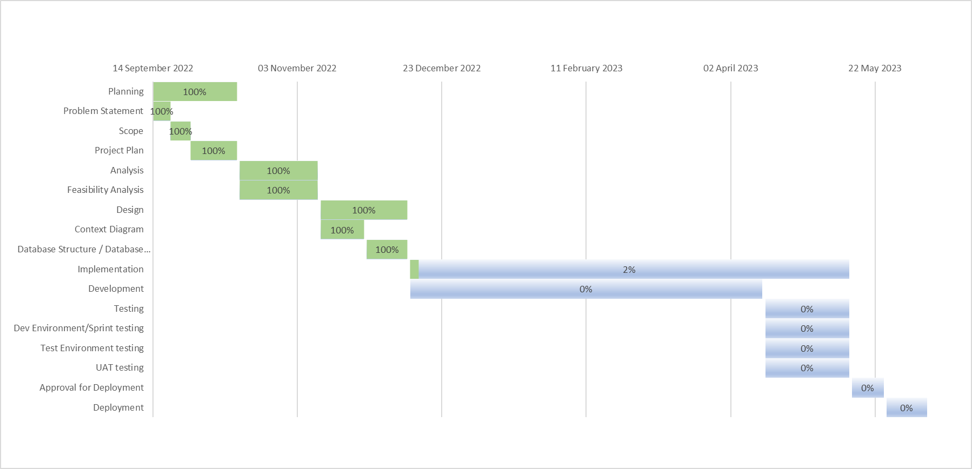

Above is the gantt chart created based on the final project plan. As visible clearly the project has completed the design phase and has started the development phase, the deadlines or timelines of the project are represented on x-axis of the graph whereas tasks are represented on y-axis. And overall progress percentage has been calculated and highlighted.

## 3.4 Development Model

**3.4.1 Waterfall + Agile Development Methodology**

The best model suitable for this project would be a hybrid of waterfall and agile model. It would be a model where we follow the waterfall model during the planning, analysis and design phase and follow agile methodology for the implementation phase which would include sprint planning for development and testing the same..

**3.4.2 Planning:** In this phase we identify the problem for the business requirements, based on the requirements we plan the project proposal and need for the business users. This phase has a complete description of the project start date and deadline as per the business policies and norms.

**3.4.3 Analysis:** The main goal of this phase is to estimate and analyze the technical, economic and organizational feasibility of the project. We need to analyze the number of members or teams required to complete the proposed project. Future scope of the project is predicted based on the analysis.

**3.4.4 Design:** Designing an enterprise model is the primary goal of this project. Database designing and entity relationship diagram need to be designed. We have an overall detailed view of the database required in this phase. Algorithms/ flow of the application and overall architecture of the project is designed.

**3.4.5 Implementation(Agile methodology):** For the implementation phase we use agile methodology. During the design phase we onboard a development team which is familiar with the system and softwares we use for this project development. Once the development team is onboarded the Scrum master divides the overall implementation phase into a different number of sprints which consists of rigorous development and testing activities. Bi-weekly or after completion of each sprint we have a client/business demo so that any further enhancements on the currently developed application would be rectified and revised accordingly. This phase follows a circular path until the implementation of the application is completed with all testing activities.  
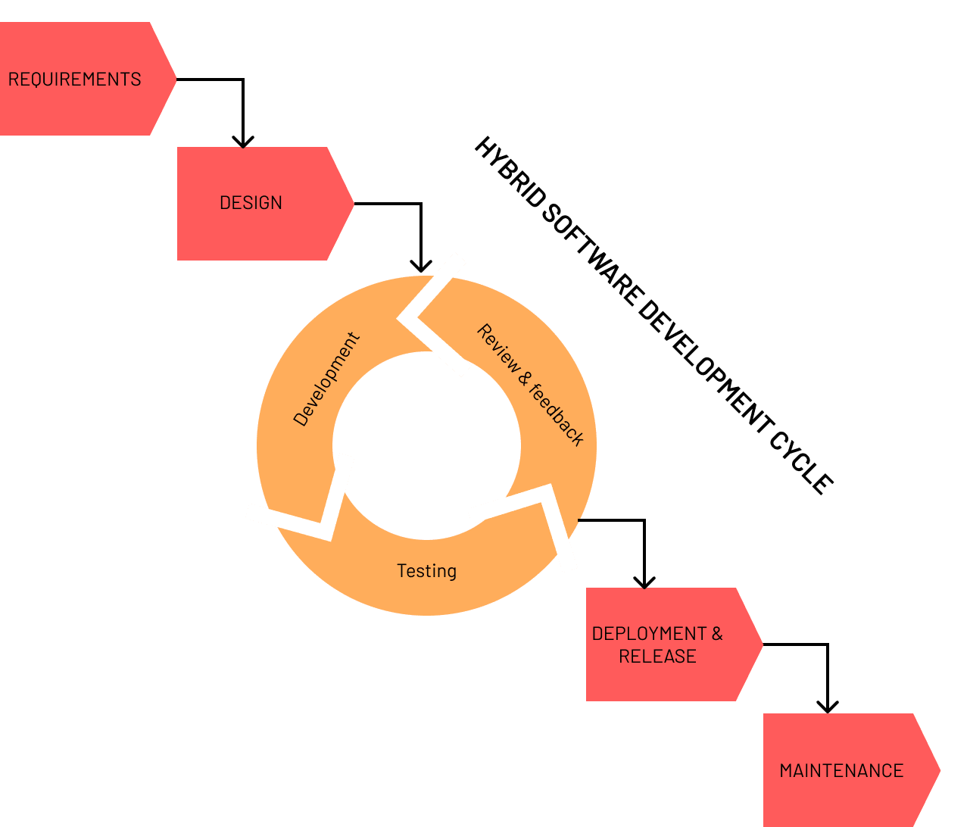

*Figure 12*

**3.4.6 Deployment:** Need some approvals to be signed off from the business team to follow smooth deployment activities. After Deployment we need to perform some of the sanity testing to make sure the application is running as expected.

**3.4.7 Maintenance:** Once the deployment is done and also the application is live we need a set of people who can maintain the application and resolve any bug that occurs in the application in future use cases.

## 3.5 Staffing Plan:

The staffing plan requires an estimation of the average number of staff needed for the project. Based on the overall planning this application requires a project manager who handles the overall team and he is the person who the team reports for any kind of change required or delay in deliverables of the project. A solution architect who can design the database and has good knowledge on the hardware and software tools required for the project is needed.

A Business analyst who is responsible for building the gap between the business and IT team is required. The primary role of a business analyst is to communicate with all stakeholders & to elicit, analyze and validate the requirements for the project. A team of developers with a team lead is required for development of the application. Approximately for this project we require One team lead along with three developers. An UI/UX designer is required in the initial design phase who can work closely with the business analyst and client to create a sample UI screen for the project. Testing is one the most important tasks which need to be performed by expert testers here at least two testers are required in this project who can rigorously test the application developed with all possible test cases.

Overall this project requires on an average of 8-10 people to make it successful.

## 3.6 Communication Plan

We are choosing the following mediums for communication.The team is expected to meet virtually, in-person once a week.

| Platform | Communication Type | Timings |
| --- | --- | --- |
| Google Meet | Virtual Meet | Sunday 11 am - 12 pm |
| Whatsapp | Chat/Call | Anytime |
| Email | Mail | Anytime |
| In-person Meeting | In-person | Tuesday 2 pm - 4:15 pm |

## 

## 3.7 Roles & Responsibilities

| Name | Roles | Responsibilities | Contribution |
| --- | --- | --- | --- |
| Suman Pogul | Manager | *Management Issues, Project Management Plan,Gantt Chart, Development Model, Communication Plan, Alternative Solution, Future Work, Student Survey Data, Entity Relationship Diagram* | 20% |
| Shraddha Kapse | Team Lead | *Introduction, System Flow, Student survey data, Development model, Current system snapshots, planning, editing, miscellaneous, Use Case, Sequence, Class Diagram* | 20% |
| Rachael Mueller | Business Analyst | *Contacting RIH, Creating User Survey, Conducting supporting research, Creating system diagrams, System Request/ Works Cited, Supporting Documentation, Editing, System Requirements, Milestones* | 20% |
| Priya Jain | Solution Architect | *Feasibility Analysis, Project Plan, Table of content, Editing, Planning, Student survey, Development Model, System Architecture Diagram, Data Flow Diagram, User Interface Design* | 20% |
| Prashanthi Sandra Grace | Developer | *System Flow, Diagrams, workflow, scope, Student Survey Data, Entity Relationship Diagram, Supporting Documentation, Project Management Plan, Conclusions* | 20% |

*Overall* - 100%

## 3.8 Milestones

* Preliminary Wireframes- November 15th
* Context Diagram- November 26th
* Databases Structure/ Database Design- December 11th
* Finalized Wireframes- December 11th
* *Development- April 13th*
* *Testing- May 13th*
* *Approval for Deployment- May 25th*
* *Deployment- June 9th*

# Requirements Elicitation Methods

This project presented unique opportunities for requirements gathering because we were redesigning a pre-existing system and were working with a nonprofit organization, the nonprofit UMBC Counseling Center. To be able to accurately assess the needs of both Counseling Center staff and student users, we relied on three main methods of requirements elicitation: reading documentation, interview, and a questionnaire.

## 4.1 Documentation

Because this project focused on a preexisting system, there were multiple sources of existing documentation to work our way through. The main three sources were reading through the forms provided by the counseling center, reading through the resources provided on the Counseling Center’s website, and compiling background research to gain insight into the patterns and needs of university counseling centers more generally. This last method was helpful specifically because data on UMBC’s Counseling Center was not publicly available, and could not easily be shared due to privacy concerns. Thus, the ability to look at aggregated trends and reports from outside sources provided estimates for information we would not otherwise have access to.

**4.1.1 Required Forms**To fully understand the features available in the current system, we downloaded required forms, explored the website, and read through resource pages. There were four main forms available on RIH’s website: the Counseling Client Authorization Information Release Form, the Health Insurance waiver, the mandatory UMBC Health/ Immunization form, the Tuberculosis Screening Questionnaire, and Advanced Directives (see Figure 1 below).

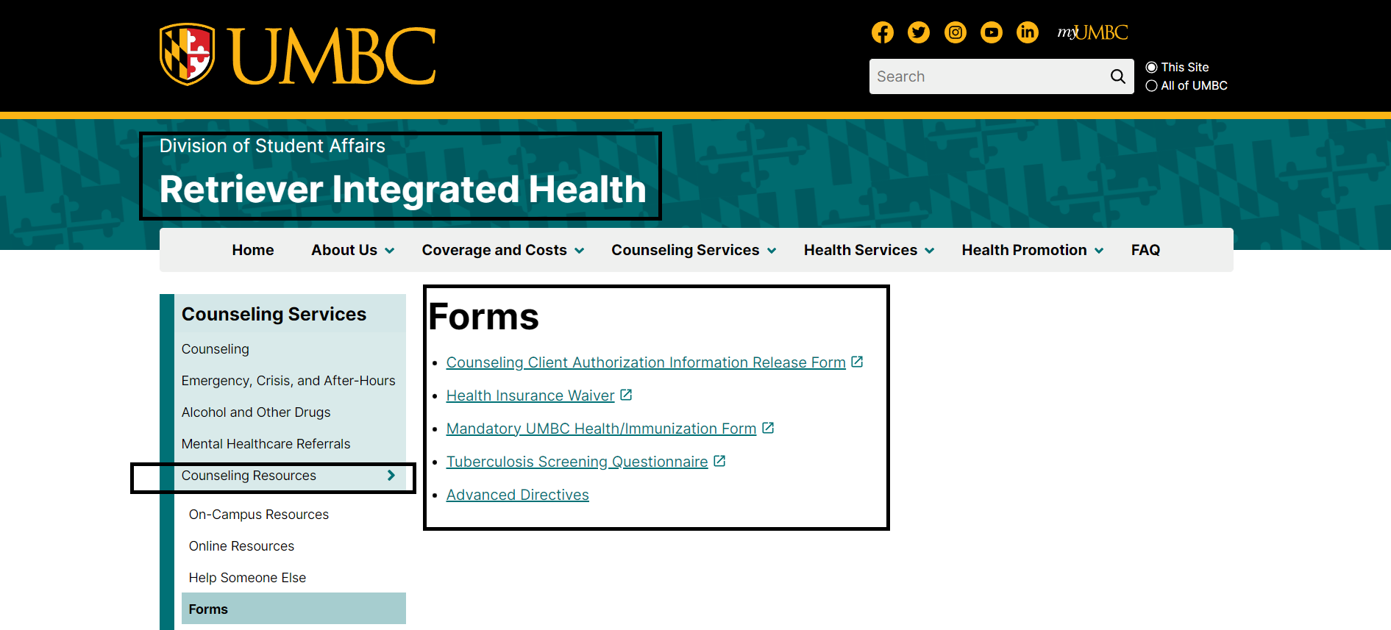

*Figure 13. Callouts added for emphasis. Links to forms available on the RIH website, under the left hand tab “Counseling Resources.”*

The current system doesn’t provide an easy way to check what forms have already been submitted, what forms need to be updated, and what forms are optional, which made the documentation somewhat confusing to navigate.

For example, the Mandatory UMBC Health/ Immunization form is mandatory for all incoming UMBC students and, as the name suggests, was primarily focused on verifying vaccinations and the dates of those vaccinations, as well as basic contact information. Thus, it is likely that a student creating an appointment would already have this form on file, but might need to update it or may have forgotten they had already filled it out. The Advanced Directive and Tuberculosis Screening Questionnaire are included in this section, but do not seem to have any bearing on a counseling appointment. Finally, the Health Insurance Waiver offers students the right to opt out of the Student health insurance plan, but requires they submit proof of insurance to do so. Since all counseling center appointments are free, and thus do not require insurance billing, this form seems superfluous.

The forms provided by the Counseling Center on their website also do not seem complete. The available forms don’t give the student any opportunity to disclose any prior mental health conditions, treatment, or concerns, to share any medications they are currently on, or to provide any description of what they would like to get out of counseling. The existing forms also do not give students any opportunity to specify whether they are interested in individual therapy, group therapy, or both, and do not allow students to request any specific counselor, or to state preferences (requesting a provider of a specific gender, or area of expertise, for instance).

Reading through the listed forms was extremely helpful in illuminating the pain points in the existing registration process. This source helped to clarify the information required, but also demonstrated areas where the current system creates confusion.

**4.1.2 Website Resources**

To fully understand the scope of the Counseling Center’s services, we read through many pages on the RIH website and student portal.

The website covered the therapeutic services provided by the Counseling Center, pointed out in-person resources located on the UMBC campus, answered common questions, and pointed out the current scheduling system (see Figure 2 below).

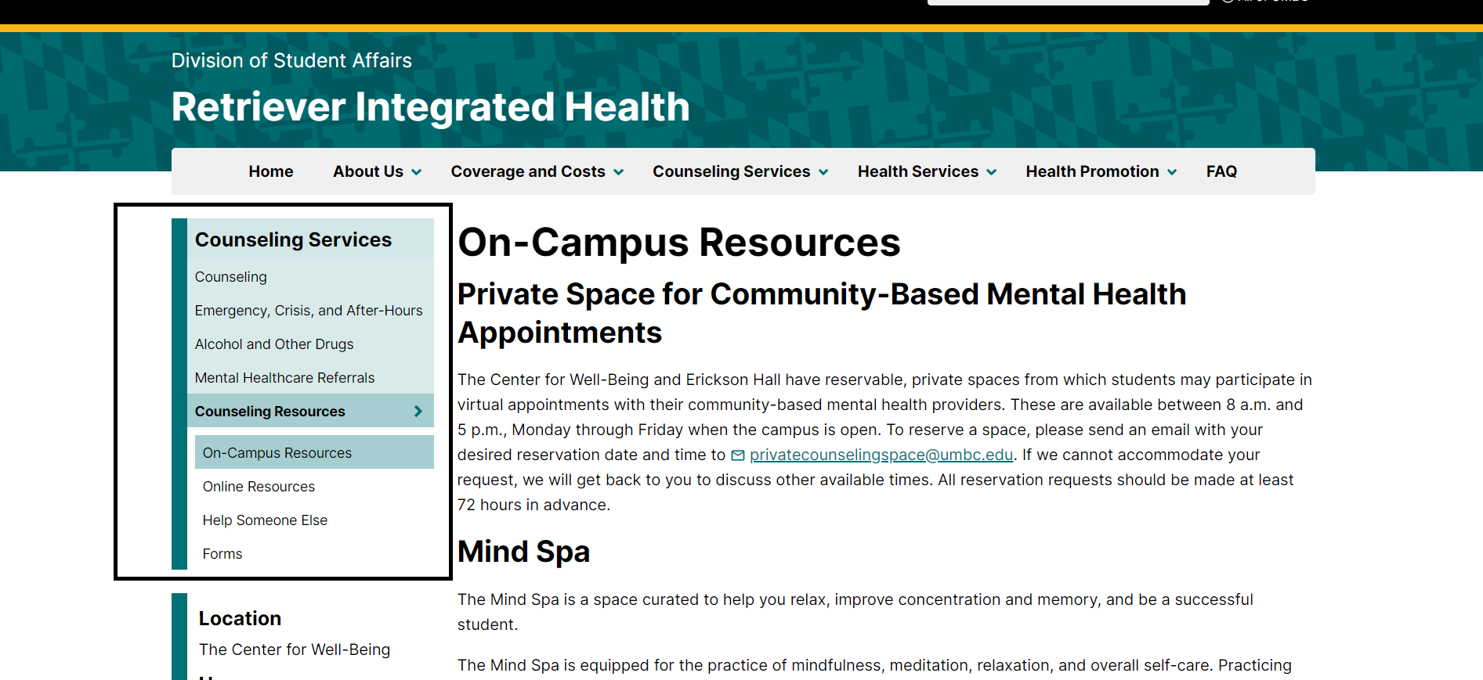

*Figure 14.**Callouts added for emphasis. RIH website menu under “Counseling Services.”*

The website materials helped us to understand the functionality offered by the current interface and identify areas of opportunity for integrating scheduling with the resources the Counseling Center offers. The RIH website also helped us to understand the interconnection between the current scheduling system and other RIH services offered through the website. Similar to other facets of the existing system, the myRetrieverCare portal was difficult to find and access. For example, in Figure 3 below, the arrangement of buttons on the page misleads the user from logging into the portal itself, and instead directs the user to the larger and more visually prominent button that links to a help video. The current difficulties in accessing the care portal helped to clarify the requirements for the new system.

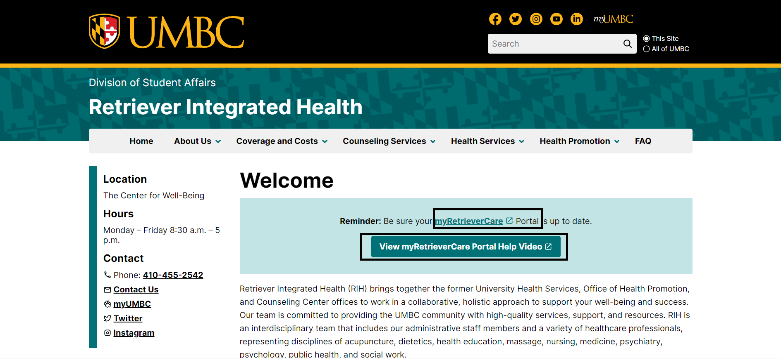

*Figure 15. Callouts added for emphasis.*

**4.1.3 Background Research**

We also conducted background research to clarify general statistics and patterns around university counseling centers because, for privacy reasons, we didn’t have full access to the data of the UMBC counseling center. When possible, we also referenced data specific to UMBC, like university budget statistics for the division of Student Affairs. This research helped us to determine approximate budgets and number of clients given the number of students enrolled at UMBC.

## 4.2 Interview

We also relied on an interview as a key facet of our requirements definition. We identified key staff members using the website and reached out directly to Dr. Bruce Herman, the Director of RIH, who connected us with Je’Nae Parker, the Assistant Director of Administration for RIH. Normally, we would have interviewed multiple staff members to gain insight into diverse perspectives of many different people who interact with the current scheduling system. Because the UMBC Counseling Center staff are busy, however, we limited our interview to Ms. Parker. We also faced challenges around scheduling that necessitated the interview be carried out asynchronously.

We submitted our prepared list of questions to Ms. Parker, who responded with the answers demonstrated in Appendix A. This interview, and the preceding email exchange, highlighted that no-show appointments brought about by incomplete mandatory paperwork were one of the primary difficulties with the existing system. It also demonstrated that Ms. Parker felt the current system was easy to use, suggesting that we should strive to maintain similar functionality on the administration side while improving student interactions. Ms. Parker also pointed to the lack of ability for students to self-schedule as an area for possible improvement.

## 4.3 Questionnaire

We also circulated a questionnaire to current UMBC students. Because the Counseling Center provides medical services, we did not want to specifically target current clients of the UMBC Counseling Center due to privacy concerns. The questionnaire helped us to understand attitudes around the current system and helped us prioritize the features that students found the most important and compelling. The complete record of our questionnaire and responses are included in Appendix B.

The questionnaire provided better insight into student perceptions and preferences around the scheduling system, and also helped to validate some of the weaknesses highlighted by the interview we conducted. For example, 57.1% of respondents did not know what steps they would need to take to schedule an appointment. Additionally, 57.1% of respondents disagreed with the statement “I know what paperwork I would need to fill out to attend an appointment at the UMBC Counseling Center,” and 28.6% of respondents strongly disagreed. The importance of this project was also validated, as 100% of respondents agreed that mental health is important to student success.

# System Proposal / System Requirements

## 5.1 Functional Requirements

Based on the above elicitation methods, the system features and associated functional requirements for this system are as follows:

## 5.1.1 F1 User Account Creation

***Description and Priority***

This feature will enable the creation and editing of a user account associated with a user’s myUMBC login credentials.

Priority: High

***Stimulus/Response Sequences***

Normal Course:

1.0 Create a user account

1. The user navigates to the “Counseling” tab of the RIH website and selects “Schedule an Appointment.”
2. The system assesses if the user is logged into a myUMBC account.
   1. If the user is already logged in with their myUMBC credentials, proceed to step 4.
   2. If the user is not yet logged in with their myUMBC account, proceed to step 3.
3. The system directs the user to log in with their myUMBC credentials.
4. The system assesses whether the user has an existing account with the UMBC Counseling Center.
   1. If the user has a preexisting account, the system will direct them to the “create an appointment” page and will not permit them to create another account
   2. If the user does not have a preexisting account, proceed to step 5.
5. The user is directed through account creation by a series of prompts that guide them through entering necessary information, including contact information, medical information, and insurance information.
6. The system securely saves the user’s data, which is viewable by authorized admin users.
7. The system displays available appointment times.

***Functional Requirements***

* F-REQ-1: The system must verify whether the user is logged into a myUMBC account.
* F-REQ-2: The system must be able to direct a user to login with their myUMBC credentials if they are not already logged in.
* F-REQ-3: The system must assess if the user has a preexisting account with the UMBC Counseling Center.
* F-REQ-4: If the user does not have an account with the Counseling Center, they must be directed through entering essential information and filling out required paperwork (TBD).
* F-REQ-5: The system must automatically save the user’s progress through account creation so they can resume if they are interrupted and must return to account creation later.
* F-REQ-6: The system should prevent the user from viewing the schedule or requesting an appointment until the necessary paperwork is filled out.
* F-REQ-7: The system should save the user’s account information and paperwork in a format that is viewable by administrators.
* F-REQ-8: The system must evaluate whether all required information is complete. If the information is complete, the system should direct the user to the scheduling calendar.

## 5.1.2 F2 User Account Editing

***Description and Priority***

This feature will enable the editing of user account information, including name, contact information, address, etc.

Priority: High

***Stimulus/Response Sequences***

Normal Course:

1.0 Edit account information

1. The user logs into their account on the RIH website.
2. The user navigates to the “My Account” section in the menu.
3. The system displays the current information on file for the user’s account.
4. The user edits the relevant information and saves their work.
5. The system confirms their account information has been updated.

***Functional Requirements***

* F-REQ-9: The system must allow the user to log into their account on the RIH website.
* F-REQ-10: The system must have a “My Account” section that allows the learner to view the information currently saved in their account.
* F-REQ-11: The system must allow the user to edit the information saved in their account.
* F-REQ-12: The system must allow the user to hit “Save” when they are finished updating their information.
* F-REQ-13: The system must confirm for a student when their information has been updated.
* F-REQ-14: The system must generate a notification to any admin users who have upcoming appointments with the student alerting them that the user’s information has been updated.

## 5.1.3 F3 Scheduling an Appointment

***Description and Priority***

This feature will enable users to request appointments at times that are convenient for them.

Priority: High

***Stimulus/Response Sequences***

Normal Course:

1.0 Schedule an appointment

1. The user logs into their account on the RIH website.
2. The user views the available time slots on a calendar.
3. The user filters available time slots based on their preferences.
4. The user selects an available time slot with a provider.
5. The system lets the user know that their request has been sent and is pending confirmation by an RIH staff member.
6. The system automatically updates the calendar to remove the time slot available for other users to request.
7. The system generates a notification to an RIH staff member alerting them to the request.
8. The system allows the RIH staff member to view and approve or reject the request.
   1. If the RIH staff member confirms the appointment, proceed to step 7.
   2. If the RIH staff member rejects the request, the system requires the staff member to email the user to discuss why the request was rejected and propose an alternate time or provider.
9. The system automatically generates an email to the user letting them know that their appointment has been confirmed.
10. The system email gives the student the option of adding the appointment to their calendar and/ or receiving a text notification reminding them about their appointment.

***Functional Requirements***

* F-REQ-15: The system must display available time slots and specify the provider.
* F-REQ-16: The system must allow the user to filter available time slots by provider, by service (individual vs group), by methodology (i.e. cognitive behavioral therapy, dialectical behavioral therapy), or by areas of expertise (i.e. grief counseling, LGBTQ+ identity, couples counseling, etc).
* F-REQ-17: The system should allow the user to view a list of their last 5 appointments, to enable users to see the same counselor if they would like to continue with the same person.
* F-REQ-18: The system should allow the user to request a specific time slot.
* F-REQ-19: The system should notify the user that their request has been sent and is pending confirmation by an RIH staff member.
* F-REQ-20: The system should generate a notification for the relevant RIH staff member that an appointment has been requested.
* F-REQ-21: The system should allow an admin user to approve or reject an appointment request.
* F-REQ-22: If the admin rejects an appointment request, the system should require the admin to send an email to the student explaining the rejection and offering an alternative.
* F-REQ-23: If the admin approves the request, the system should automatically generate an email to the student notifying them that their appointment request has been confirmed.
* F-REQ-24: The system should allow the user to opt-in to adding the appointment to their calendar and/ or receiving text message reminders about their upcoming appointment.
* F-REQ-25: The system should automatically remove pending and approved appointments from the available time slots visible on the calendar so other users cannot request an appointment with that provider during that time.

## 5.1.4 F4 User Canceling an Appointment

***Description and Priority***

This feature will enable users to cancel upcoming appointments.

Priority: High

***Stimulus/Response Sequences***

Normal Course:

1.0 Cancel an appointment

1. The user logs into their account on the RIH website.
2. The user views their upcoming appointments.
3. The user selects an upcoming appointment.
4. The system asks the user if they would like to cancel this appointment.
5. The user selects “Yes.”
6. The system evaluates the time frame of the upcoming appointment.
   1. If the appointment is within the next 24 hours, the system will prevent the user from canceling and display a message with the RIH phone number instructing students that canceling with less than 24 hours’ notice requires calling RIH staff to let them know.
   2. If the appointment is more than 24 hours away, proceed to step 7.
7. The system removes the appointment from the students’ calendar and displays a confirmation message letting them know the appointment has been canceled.
8. The system automatically generates an email to RIH staff alerting them to the cancellation.
9. The system updates the calendar to make the canceled time slot available for other users to request.

***Functional Requirements***

* F-REQ-26: The system must allow the user to view upcoming appointments in chronological order.
* F-REQ-27: The system must allow the user to select a specific appointment and delete it.
* F-REQ-28: The system must generate a message saying “Are you sure you want to cancel this appointment?” to ensure students do not accidentally delete appointments.
* F-REQ-29: The system must automatically update the available time slots calendar to enable other users to request that appointment time with that provider when an appointment has been canceled.
* F-REQ-30: The system must automatically generate a notification for the counselor letting them know the appointment has been canceled.
* F-REQ-31: The system must evaluate whether the appointment is occurring in the next 24 hours.
* F-REQ-32: If the appointment is occurring in the next 24 hours, the system must prevent the user from canceling on the website, display the counseling center phone number, and inform the user that canceling appointments within 24 hours requires calling the counseling center directly.

## 5.1.5 F4 Admin Canceling an Appointment

***Description and Priority***

This feature will enable administrators to cancel upcoming appointments.

Priority: High

***Stimulus/Response Sequences***

Normal Course:

1.0 Cancel an appointment

1. The admin logs into their secure account, which requires two-factor authentication.
2. The admin views their upcoming appointments.
3. The admin is able to select a specific appointment and cancel it.
4. The admin enters a message to the user explaining the cancellation.

***Functional Requirements***

* F-REQ-33: The system must allow administrators to log into individual accounts using two-factor authentication.
* F-REQ-34: The system must allow admin users to view their upcoming appointments.
* F-REQ-35: The system must allow admin users to select individual appointments and delete them.
* F-REQ-36: The system must display a confirmation message to make sure the admin does not accidentally delete an appointment.
* F-REQ-37: The system must require the admin to send a message to the user explaining the cancellation.
* F-REQ-38: The system must automatically make the time slot available to other users to request.

## 5.1.6 F5 Creating an Admin Account

***Description and Priority***

This feature will enable admin accounts with editing permission to create other admin accounts and set permissions for them.

Priority: High

***Stimulus/Response Sequences***

Normal Course:

1.0 Create an admin account

1. An admin with account creation permissions selects “create account.”
2. The admin with account creation permissions enters a UMBC employee’s staff credentials.
3. The new UMBC staff member sets up a password.
4. The new UMBC staff member sets up two factor authentication.

***Functional Requirements***

* F-REQ-39: The system must have permission levels that allow only specific admin accounts to create other admin accounts.
* F-REQ-40: The system must allow admins with account creation permissions to create new admin accounts.
* F-REQ-41: The system must generate an email alerting the new UMBC staff member that an account has been created for them and requesting that they set up a username and password.
* F-REQ-42: The system must require the new UMBC staff member to set up two factor authentication.
* F-REQ-43: The system must confirm to the admin creating the account that the account has been created.

## 5.1.7 F6 Setting Availability

***Description and Priority***

This feature will enable admin accounts to edit their calendar availability.

Priority: High

***Stimulus/Response Sequences***

Normal Course:

1.0 Edit availability.

1. An admin logs into their account using two factor authentication.
2. The admin views their calendar availability.
3. The admin selects any blocks of time during normal Counseling Center operating hours that are unavailable and mark themselves as unavailable.

***Functional Requirements***

* F-REQ-44: The system must allow admin users to view their calendar availability.
* F-REQ-45: The system must allow admin users to select blocks of time and mark them as unavailable.
* F-REQ-46: If the counselor selects a block of time during which they have an upcoming appointment, the system must display an error message, prevent them from marking the time as unavailable, and ask if they would like to cancel the appointment.
* F-REQ-47: The system must allow admin users to mark specific times as unavailable on a weekly repeating basis.
* F-REQ-48: The system must automatically block off times during which the Counseling Center is not open (i.e. outside of business hours and during university holidays).

## 5.2 Non-Functional Requirements

## 5.2.1 Performance Requirements

* NF-REQ-1: The network transaction response time must be less than 3 seconds.
* NF-REQ-2: The system must be capable of supporting a maximum of 1,700 users at a time.
* NF-REQ-3: The system must have 99% uptime performance.
* NF-REQ-4: The system must automatically save user-entered information every 5 seconds.
* NF-REQ-5: The system must update available time slots within 2 seconds of a request or update being made.

## 5.2.2 Safety Requirements

* NF-REQ-6: The system must display an option for immediate help that links the user to the National Suicide Prevention hotline.
* NF-REQ-7: The system must provide confirmation messages for any changes to ensure appointments are not accidentally deleted.
* NF-REQ-8: Any calendar events or text message notifications reminding the user of upcoming appointments will use generalized language and avoid any language that could inadvertently reveal that the user is seeing a mental health provider. Titles will use generalized terms like “appointment.”

## 5.2.3 Security Requirements

* NF-REQ-9: Client data can only be accessed through a secure portal by Counseling Center staff.
* NF-REQ-10: All admin accounts require two factor authentication.
* NF-REQ-11: Clients can only access their own scheduling data; all other data appears as anonymized “available/ unavailable” on the calendar.
* NF-REQ-12: Data will be encrypted from the user to the website.
* NF-REQ-13: All system activity will adhere to HIPAA privacy and security standards.

## 5.2.4 Software Quality Attributes

* NF-REQ-14: The system will be available on desktop, ioS and Android mobile systems.
* NF-REQ-15: The system will be easy to navigate for the average university student.
* NF-REQ-16: Wherever possible, text fields and messages within the system will be emotionally supportive and appealing.
* NF-REQ-17: To motivate students to complete the required paperwork, the system will display progress and encourage the user through motivational messages between individual steps.

## 5.2.5 Business Rules

* NF-REQ-18: Only admin accounts utilized by the IT department or selected by the IT department can create other admin user accounts.

## 5.3 Data Flow Diagrams

A context diagram consists of the data flow of the whole system in a concise manner. It gives you the brief description of the system yet includes all the important information of the systems’ data flow. The data flow is represented in the identified entities and their processes. An important thing to remember is that a context diagram does not have any kind of data storage in it. At this stage you cannot have storage. The sub-processes of the diagram are further explained in the level-0 diagram.

Below drawn is the context diagram of the UMBC counseling scheduling system application. The User is the person who wants to book an appointment via the application by looking at available slots, and get the confirmation details once the appointment is booked. A Counselor is the person who would be having the client (User) information such as their name, medical history, etc. The counselor would also provide their slot availability details to the scheduled appointment process and in the end would receive a confirmation notification from the process as well.

The process of Schedule appointment online contains the details from the client (Student) and slot availability details from the counselor and would send a confirmation notification to both of the entities once the appointment is fixed.

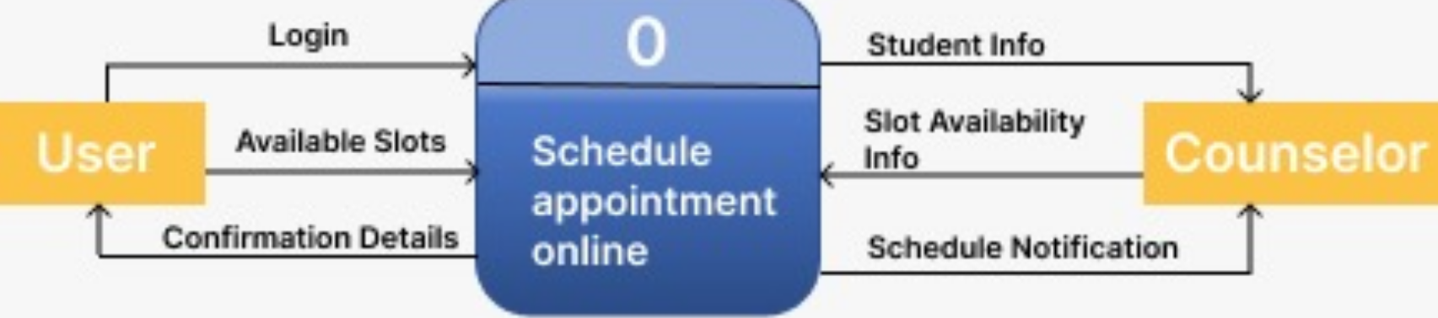

*Figure 16. Context Diagram*

The second instance of the data flow diagram consists of Level-0. The sub-processes of the context diagram are explained in the level-0 diagram. The external remains the same as the context diagram which are - the User and the Counselor. The Processes mentioned in the below diagram are create account (1), check slot availability (2), schedule appointment (3). The Data stores mentioned in the flow diagram are - User Details (D1) and Appointments (D2). When the Client (User) logs in the data store D1 confirms that they are authorized users. The scheduled/rescheduled/canceled appointments are stored in data store D2. The data store D2 also withholds the appointment status (whether confirmed or not). The Data store is accessed whenever the client logs in and books an appointment. Another Data store D2 is used to send the status of the appointment to the identified entities.

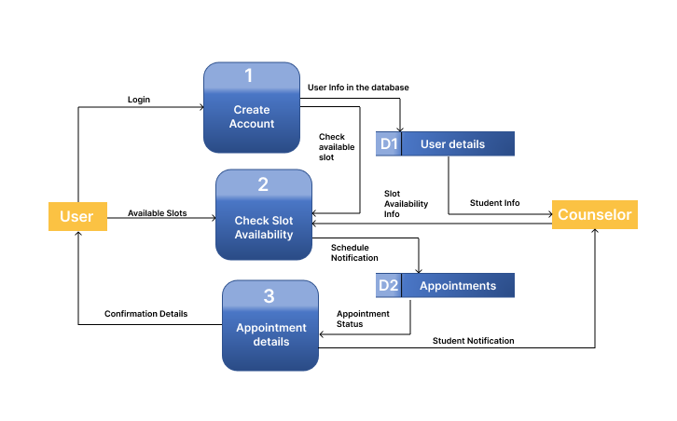

*Figure 17. Level 0 Diagram*

The third instance for a data flow diagram is the level-1 diagram. The sub-processes of the level-0 diagram are explained in the level-1 diagram. Here, the external entities remain the same. The processes are - Input User details (1.1) and Identity Authorization (1.2). The Data stores used in this sub-process is - User Details (D1). The Process 1.1 takes input from the client such as their details. The details are further passed to the process 1.2 for authorization. The Process 1.2 further goes to the data store D1 to save the details for further use and to the Process 2 explained in level-0 diagram.

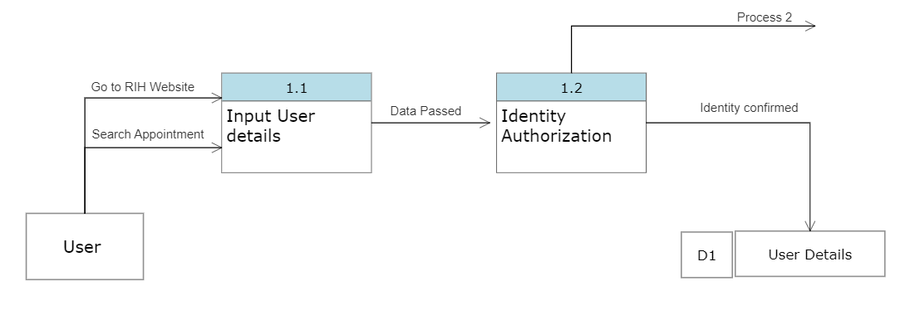

*Figure 18. Level-1 Diagram*

## 5.4 Use Case Analysis

Use cases and use case diagrams show how the user interacts with the product designed. Use case diagrams show the high-level functionality of the system. Use case diagrams depict how the user interacts with the system and shows how they relate to the many use cases they are involved in. Use Case diagrams makes it simpler for you to view the System on the most initial level. Actors, use cases, and their relationships are some of the components that make up use case diagrams. The use case breaks down to a number of possibilities for a particular scenario from the use case diagram's broad overview of the plan.  
  
The below mentioned points are the identified Actors, Use cases and their relationship in the System -

1. **Actors** - Actors are the user that interacts with the system.  
   a. Client (Student)

b. Counselor

c. Patient record system

1. **Use Cases and its relationship with the actors** -

a. Create account - The use case enables a student to validate their information with the system and create an account. The User has to enter their UMBC Login details for the authentication while logging into the system.

b. Make an appointment - This use case enables the users (both Student and the counselor) to make an appointment. Details such as availability of the counselor, history of the client are required to make the appointment.

c. View appointment - It enables the client and the counselor to view their available appointments.

d. Contact client - This feature enables the counselor to contact the client via the contact information the client has provided such as - email, phone number.

e. Contact counselor - This feature enables the client to contact the counselor via the contact information the counselor has provided such as - email, phone number.

f. Cancel appointment - The use case is used both by the counselor and the student to cancel any upcoming appointments.

g. Reschedule appointment - This use case enables the counselor as well as the client to reschedule the appointment as per their convenience.

h. View resources - The client is able to view all the available dates of the counselor to make appointments.

i. Edit records - The client uses this feature to edit the recorded details entered by them. The counselor uses the same to edit records if any.

j. Appointment notifications - The patient record system notifies the counselor and the student regarding the appointment confirmation, appointment rescheduling, and appointment cancellation.

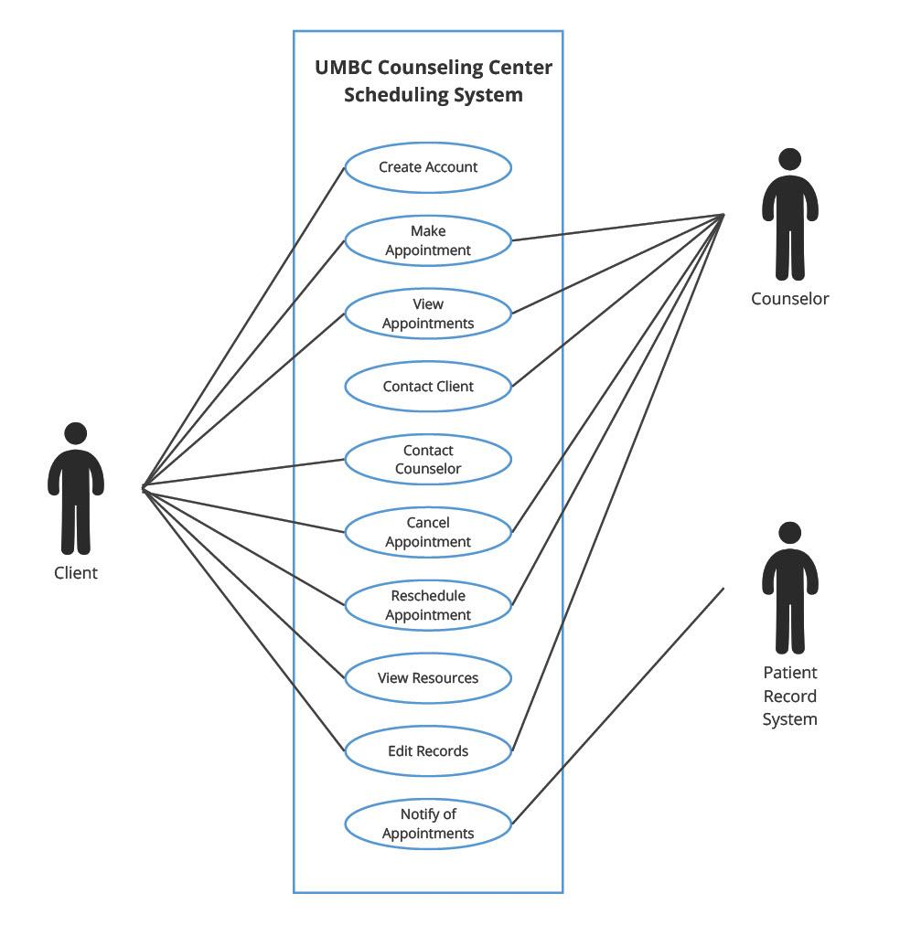

*Figure 19. Use case diagram*

The below figure represents the second use case diagram of the System of client to create an account in the System. The System first prompts the user to enter their details. The details can contain information such as their name, campus ID, age, date of birth, etc. The Patient record system then asks the client to confirm their identity which could be done by verifying their student email id or through a text message.

Once the client identity is confirmed the data is added to the systems’ database and an account is created successfully.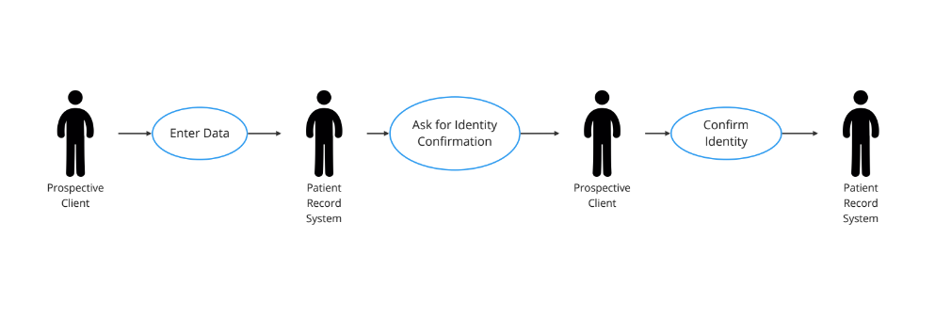

*Figure 20. Use case diagram flow of the user to create an account*

The below diagram depicts the third use case diagram of the proposed system that shows how to schedule an appointment. Firstly, the client logs into the system via the account created by them. The clients are then shown the appointment options i.e. the date of availability, available counselors, etc. The client then raises the request for appointment in the system. If the client and counselor both are available at the confirmed date, the appointment is confirmed. And a notification is sent to the client.

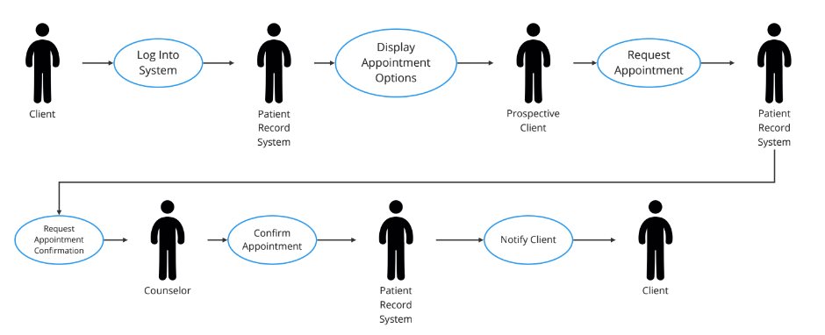

*Figure 21. Use case diagram flow to schedule an appointment with the counselor*

## 5.5 Class Diagram

A class diagram is identified as a structural diagram in the Unified Modeling Language that means its structure is static which describes the Systems’ structure by identifying the Systems’ major classes, their attributes, methods (Operations done by the classes), and the relationship between them. A class is an object that consists of attributes and behavior. The behavior tells us about the Operations the object might perform. A class might share a relationship with the other identified classes.

The figure below shows the class diagram for the UMBC Counseling system application. Following are the major classes and their attributes identified for the proposed system -

1. Client (Student) - The features of the client class includes name of the student, Campus ID, Date of Birth, Email Id, and Gender of the Client.
2. Counselor - The static features of the Counselor includes Name of the Counselor, their date of availability and Email id.
3. Patient Record System - The features include details of the Client such as Client Name, their Medical History, Problem description and a signed consent form from the client.

Below are the behavioral features of the classes -

1. Client (Student) -
2. book_appointment() - The user books an appointment.
3. reschedule_appointment() - The client reschedules an appointment.
4. cancel_appoinment() - The client cancels an appointment.
5. do_paperwork() - The user does the required paperwork on or before the date of appointment.
6. Counselor -
7. view_appointment() - The Counselor views the confirmed appointment.
8. reschedule_appointment() - The Doctor can reschedule an appointment.
9. cancel_appoinment() - The Counselor cancels an upcoming appointment.
10. view_client_paperwork() - The Counselor reads the Clients’ information updated in the database.
11. Patient Record System -
12. notify_client() - The System notifies the client with an alert mail or message regarding the appointment confirmation, rescheduling, or cancellation of the appointment.
13. notify_counselor() - The System sends a mail or message notification to the Counselor with the appointments’ confirmation, rescheduling or cancellation.

The classes are involved with other classes in such a way -

1. One Student has only one Counselor, unlike the Counselor who can have multiple Clients (Students).
2. One Client has to give his/her details to the Patient record System only once. The Patient record System can contain data from numerous Clients.
3. A Counselor can have access to multiple clients’ data they have undergone therapy. While the system will give access to view the undergoing Clients’ details.

The Class diagram thus depicts the basic structure of the system.

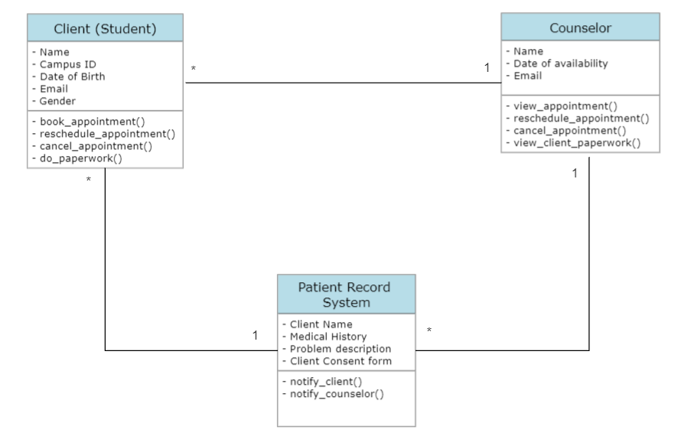

*Figure 22. Class Diagram*

## 5.6 Entity-Relationship Diagram

The below diagram represents Entity Relationship Model (ERD). A basic ER model consists of entity types and its relationships that exist between the entities. An ER model is often developed in software engineering to illustrate the information that an organization must be aware of in order to execute business activities. As a result, the ER model is transformed into an abstract data model that specifies a data or information structure that can be used in a database.

The following ERD is created for the UMBC Counseling Center system. Entities are shown in a box represented with a blue icon (box). All the unique ids (primary keys), attributes are shown along with foreign keys. Due to the nature of the information system, many operations fall under many-to-many cardinality. This is depicted by a solid line with three branches at the end. This line with the three branch lines indicates a one to many relationship which is depicted in the figure below.

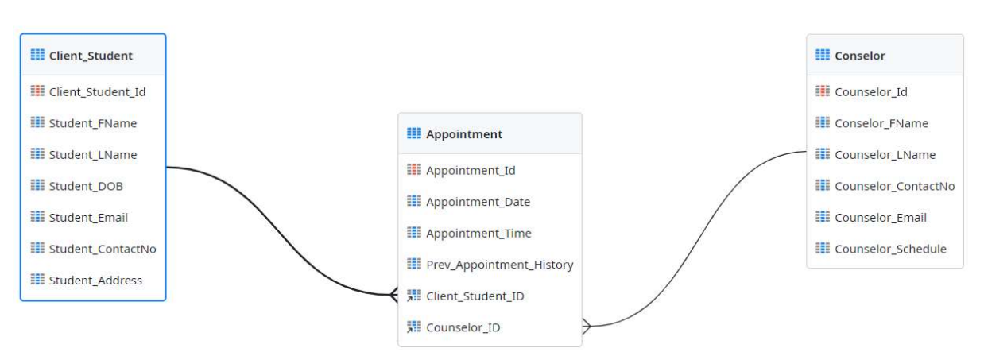

*Figure 23. Entity-Relationship Diagram*

Following entities are identified for the Entity-Relationship Diagram -

1. **Client / Student Entity** - Client or Student Entity is the person who schedules an appointment for counseling through this application. The client needs to create an account in the portal if he/she is a new user. After successful login into the application, they need to provide some of the basic information mandatorily such as First name, Last name, Email Id, Contact No, Address .... The Client then can check to book an appointment based on the availability of the counselor.
2. **Counselor Entity** - Counselor Entity stores the data about the counselor such as First name, Last name, Email Id, Contact No and schedule of availability. Counselors can view the client information through appointment details.
3. **Appointment Entity** - Consists of all the information related to appointment details such as Appointment date, time and also consists of client and counselor details as an foreign key attributes. The appointment entity also stores the previous history related to all the appointments of a client.

## 5.7 Sequence Diagram

A sequence diagram displays the sequential flow of the application. It depicts the sequence of the System, the messages exchanged between the users and the system in a sequential way. The sequence diagram is a great way to comprehend the systems’ flow as it gives you the order of the numerous identified flows of the application. Sequence diagrams are used to view the logical flow and correlation in the system.

The diagram gives high-level depiction of the relationship between the active user and the system. It models the active interaction of the system with its user to produce another use case. The horizontal lines tell you about the operation involved in an orderly way. The vertical line, also known as the lifeline, depicts participation of an individual user. The horizontal dotted lines represent the return message of the communication, basically, responding back to the caller user with a message. The identified use case scenarios (actors that interact with the system) are depicted in sequential order.

Given below is the identified Sequence diagram for the UMBC counseling scheduling system. Here, the Client and Counsellor are identified as the major actors including the System. The System flow starts with the User authentication by entering details by the student. These login details are validated while the client creates an account with the system. Once the user is authenticated, a request can be raised by the student to schedule an appointment. On this step, the Counselors’ availability is provided to the student by the system as shown in the figure. Further, the student chooses the date as per their convenience and confirms the appointment. A notification is sent to the counselor with the students’ date of confirmation and the appointment is confirmed and the student receives an alert about the same via email.

Once the appointment is confirmed, Students are then required to fill out two forms namely – Consent form and their medical history details form which are saved to the system’s database. These details are further fetched by the counselor from the System on the day of appointment for he/she to refer it.

The System flow right from the client creating an account to the Counselor fetching the details of the client is shown in the figure below in an orderly manner.

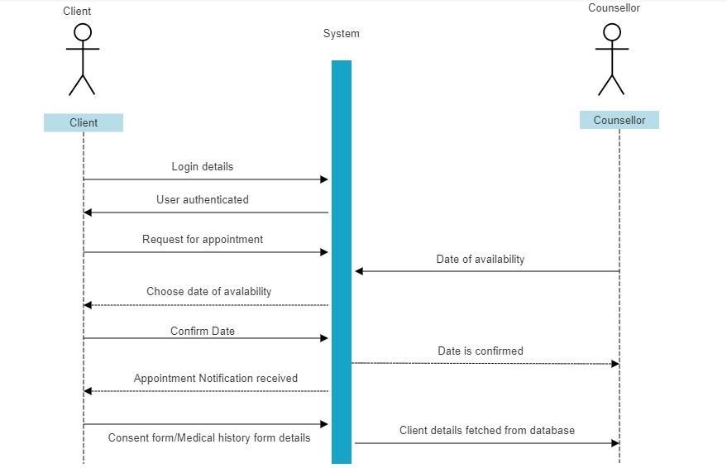

*Figure 24. Sequence diagram*

# Design

## 6.1 Architecture Design

A system architecture is a conceptual model that defines the structure, behavior, and views of a system. A formal description and representation of a system that is set up to facilitate analysis of its structures and behaviors is called an architecture description. A system architecture can be made up of designed subsystems and system components that will cooperate to implement the whole system. It has been attempted to codify languages that describe system architecture; these are referred to as architecture description languages collectively.

The development and analysis of a construction project takes place in stages according to the architectural design process. This procedure is often divided into seven parts to give the project structure by selecting review intervals, developing a structured release of design information, and identifying the stages of natural invoicing. The architecture design, which details the system's hardware, software, and network environment, is a crucial part of the design phase. The operational, performance, security, cultural, and political needs are the main nonfunctional criteria that influence architecture design.

The architectural design process is crucial because it streamlines project management and provides explicit explanations of the design objective. The stages of the architectural design process provide efficient and transparent production information to lower risks that could cause expensive, unanticipated delays.

Given below is the architecture diagram for the UMBC counseling scheduling system. The system starts with the Homepage of the myRetriever Care website. If the user is new, then they have to create the account to enter the profile and to check the records. Else, the user can directly login to the account and access the information. When creating the account the patient records are collected from the system and have to answer the predefined quiz to set up the profile. The existing user can login with the username and password. In the appointment scheduling step, the users can select appointments using the scheduling system. The system provides the available time slots and request options for the user to book appointments. It also provides the remainder feature such that if the students want reminders they can opt-in the appointment reminders or else they can opt-out. Once the students opt-in for the appointment, the counselor approves the request by checking the user account. If the account is on hold, then the counselor emails the student to resolve the issue. If there is no hold then the student receives an appointment confirmation via email. Below *Figure. Architecture Diagram* depicts the mentioned process.

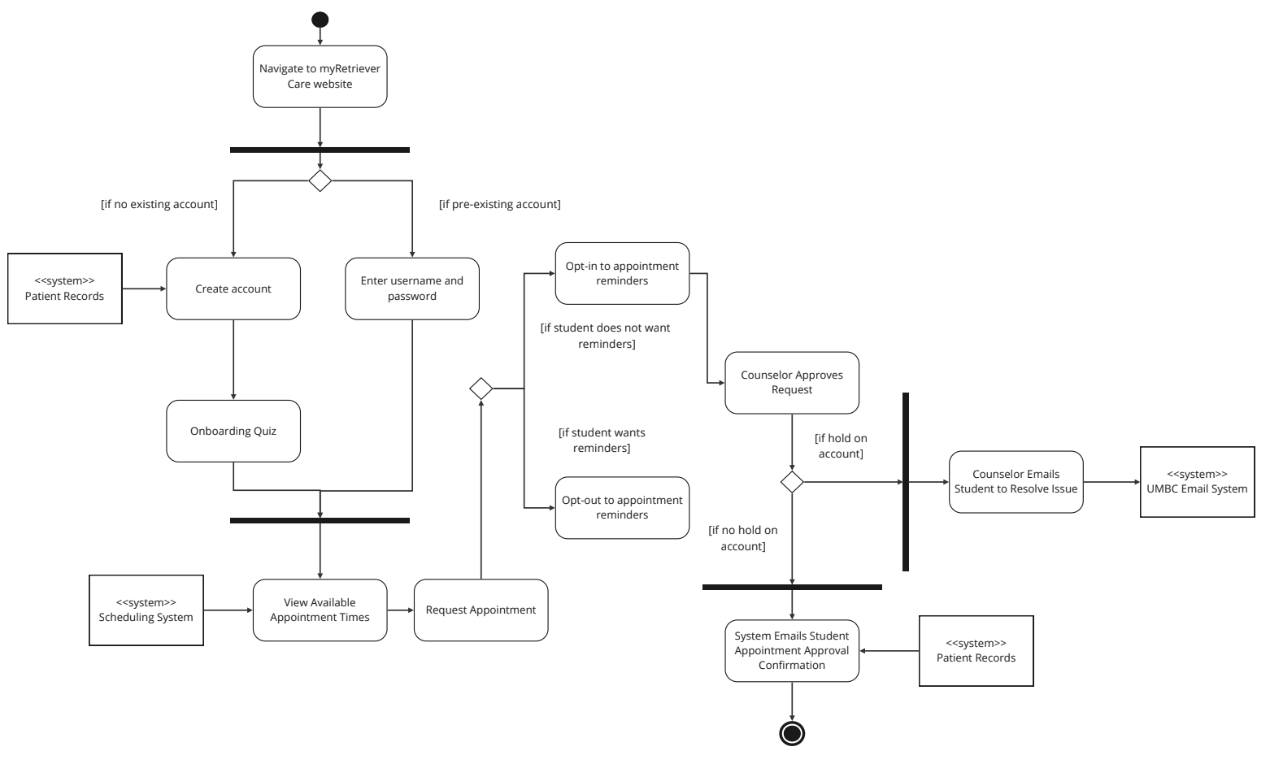

*Figure 25. Architecture Diagram*

Compatibility charts for hardware and software are shown below. And all stable Product versions will be used in our application to ensure that the system is error-free.

## 6.2 Hardware compatibility

| Processor | Intel Core i5 or higher |
| --- | --- |
| RAM | 8 GB or greater |
| Storage | 250 GB or more |
| Input Devices | Mouse or Touchpad |

## 6.3 Software compatibility

Any IT project is constructed on the three pillars of front-end, back-end, and server. We are concentrating on the following competencies for our project.

a) Front End: React Js

b) Java Spring Boot API with the most recent Java 8 Features for the back end

c) Database and Server: MySQL

applying the aforementioned Expertise as a result Our project seems to be sound technically.

| Technology | Stable Version | Latest Release |
| --- | --- | --- |
| React JS(Front End) | React 17 | React 18 |
| Java(Back End) | Java 8 | Java 12 |
| My SQL | MySQL 5.7 | MySQL 8.0 |

## 6.4 User Interface Design

The technique that designers use to create user interfaces in software or electronic devices with a focus on aesthetics or style is known as user interface (UI) design. Designers strive to produce user-friendly and enjoyable interfaces. In our instance, apps and websites, a user interface (UI) is the area where interactions between people and machines take place. Graphical user interfaces and other types are referred to as "UI design."

The UI designer focuses on creating wireframes that take into account suggestions from the UX designers as well as meeting all of the brand requirements. Every little thing is attended to by UI designers, from font to logo usage, and they make sure that every project they work on is consistent with other touch-points. You might want your app, website, and landing pages to all appear the same, as an example. UI designers have the ability to innovate the design at the same time. They can develop more inventive ways to convey information because they get to concentrate more on the creative aspect of the project.

**6.4.1 Wireframes**

The job we conduct on the modern web today includes designing and constructing websites that function on a variety of devices. We are being forced to reconsider how we lay out our website designs and how we make our pages smoothly match the device they are being seen on by responsive design. Nowadays, we hardly ever begin a design without first engaging in some kind of wireframing procedure.

A wireframe is the basic structure of the page, typically depicted with simple forms, lines, and styling. The key is to concentrate on determining layout and content placement as well as finding solutions to navigational and functional issues in a format that is flexible. I recognize that shifting our perspectives on these layouts and deciding on a new course might be somewhat difficult. We can prioritize site items while putting them in the best possible order by wireframing for mobile devices first (or from narrow widths outwards).

For the proposed system we choose to prepare some paper wireframe which is a sketch that shows the basic structure of an app or website. As the name implies, it is frequently used for quick simulation and testing on paper or a whiteboard with a pencil or a pen. The key is to concentrate on determining layout and content placement as well as finding solutions to navigational and functional issues in a format that is flexible.

Below are few wireframes with all the major changes proposed in the presentation:

*Figure. Wireframe1: Before Login Page :* To give a general sense of the suggested appointment schedule button ‘Schedule an appointment’ on the landing page, this wireframe has been produced.

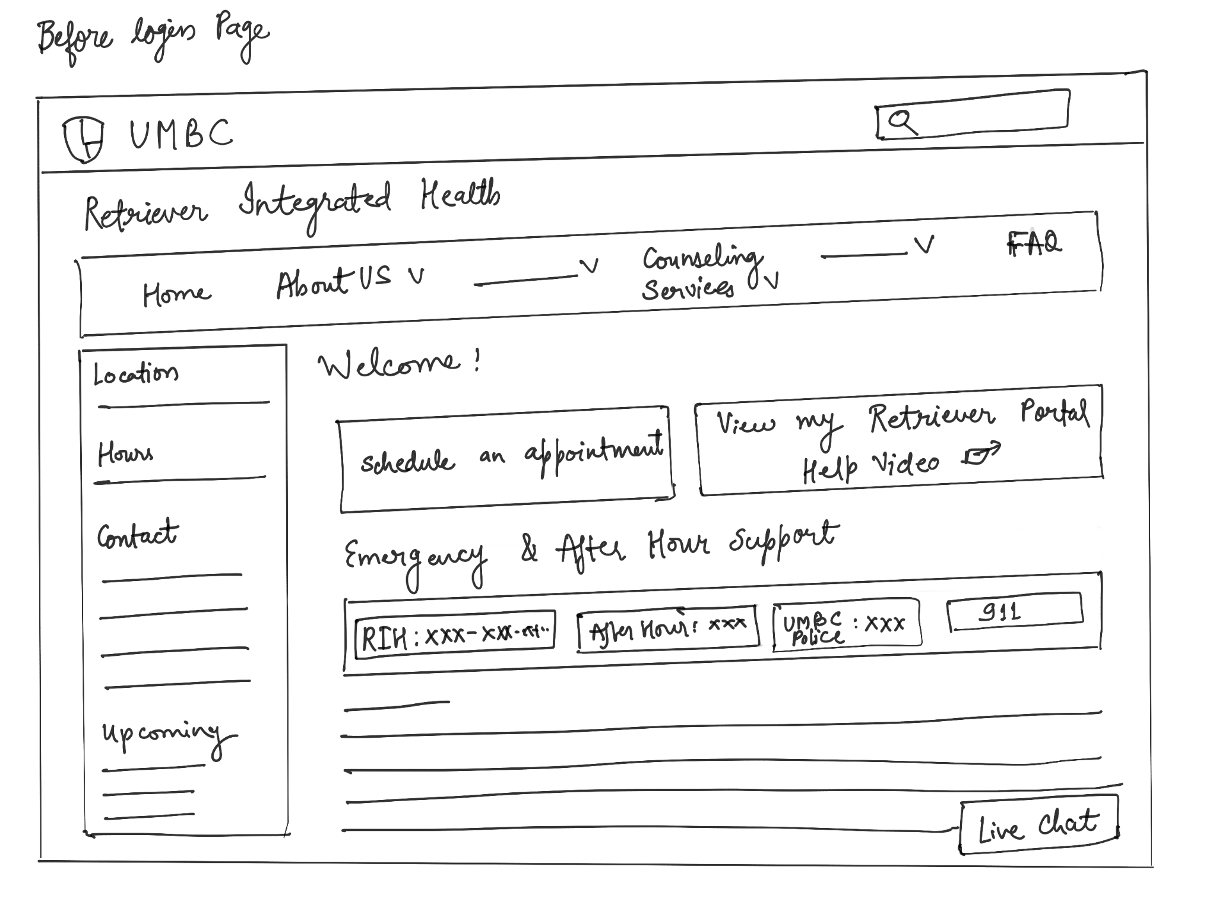

*Figure 26. Wireframe1: Before Login Page*

*Figure. Wireframe2: Before Login Schedule Page :* This wireframe's goal is to illustrate how a desired appointment may be found and selected, as well as how necessary information might be obtained, using a "Live Chat" system.

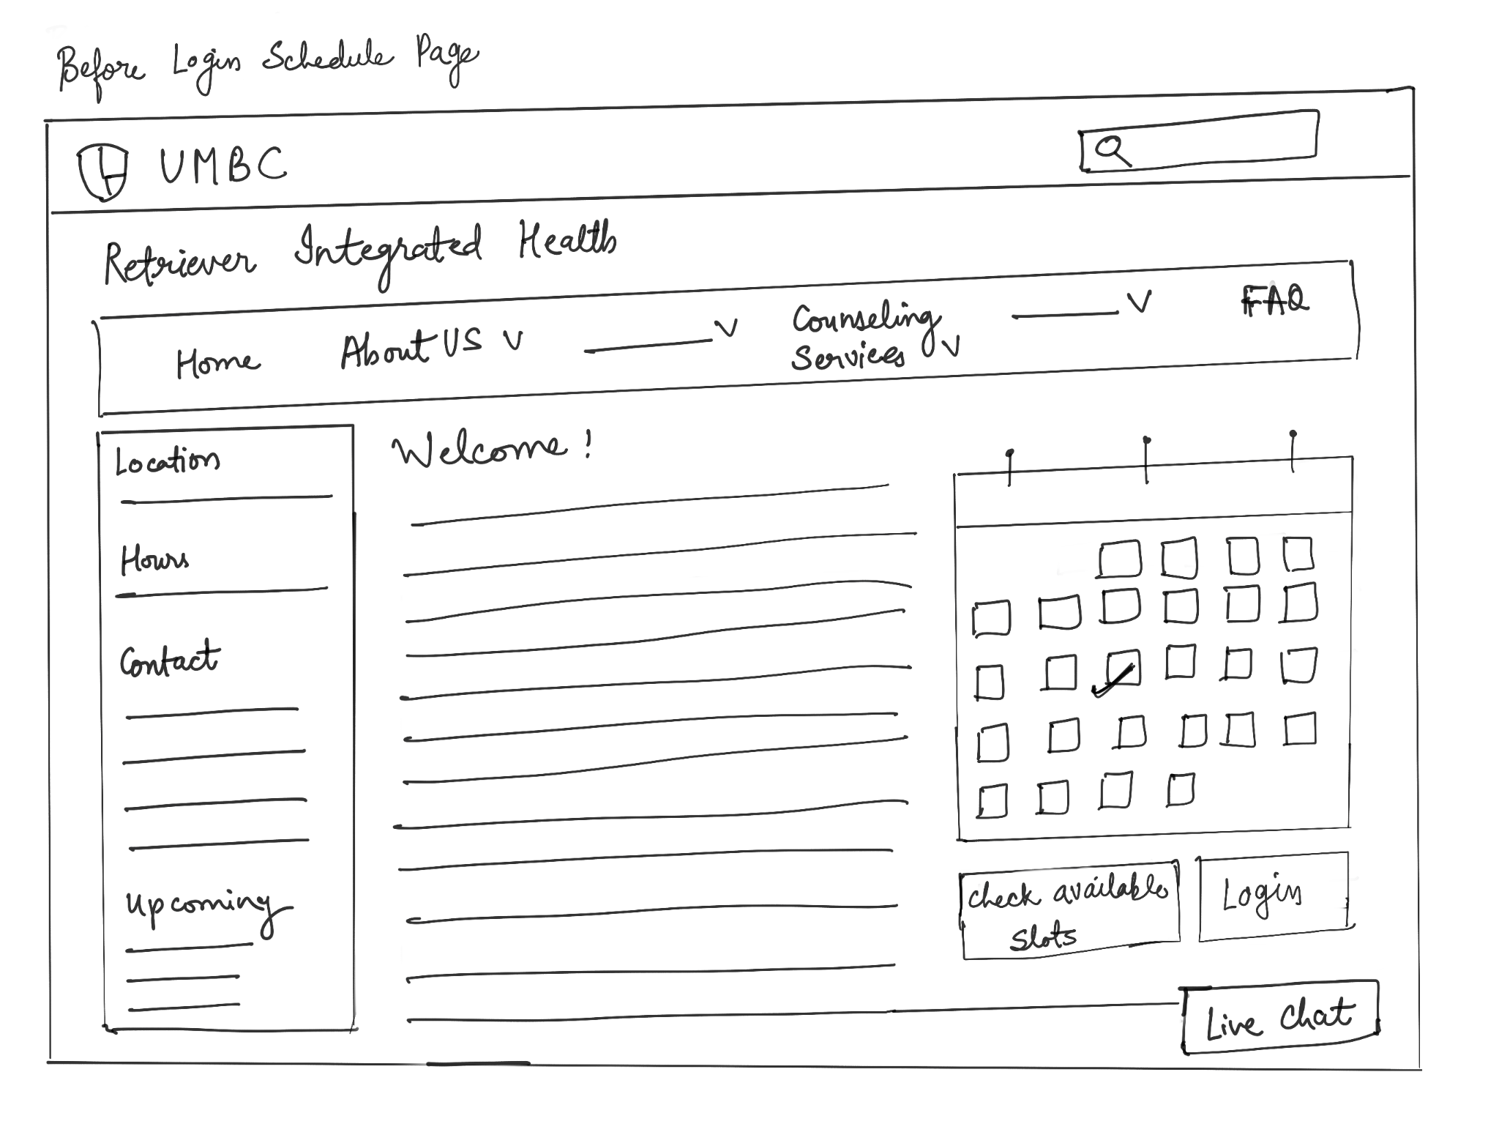

*Figure 27. Wireframe2: Before Login Schedule Page*

*Figure. Wireframe3: After Login Page :* This screen wireframe provides you with an understanding of how a cancel button might be added in the event that you forget about your appointment or decide to cancel it.

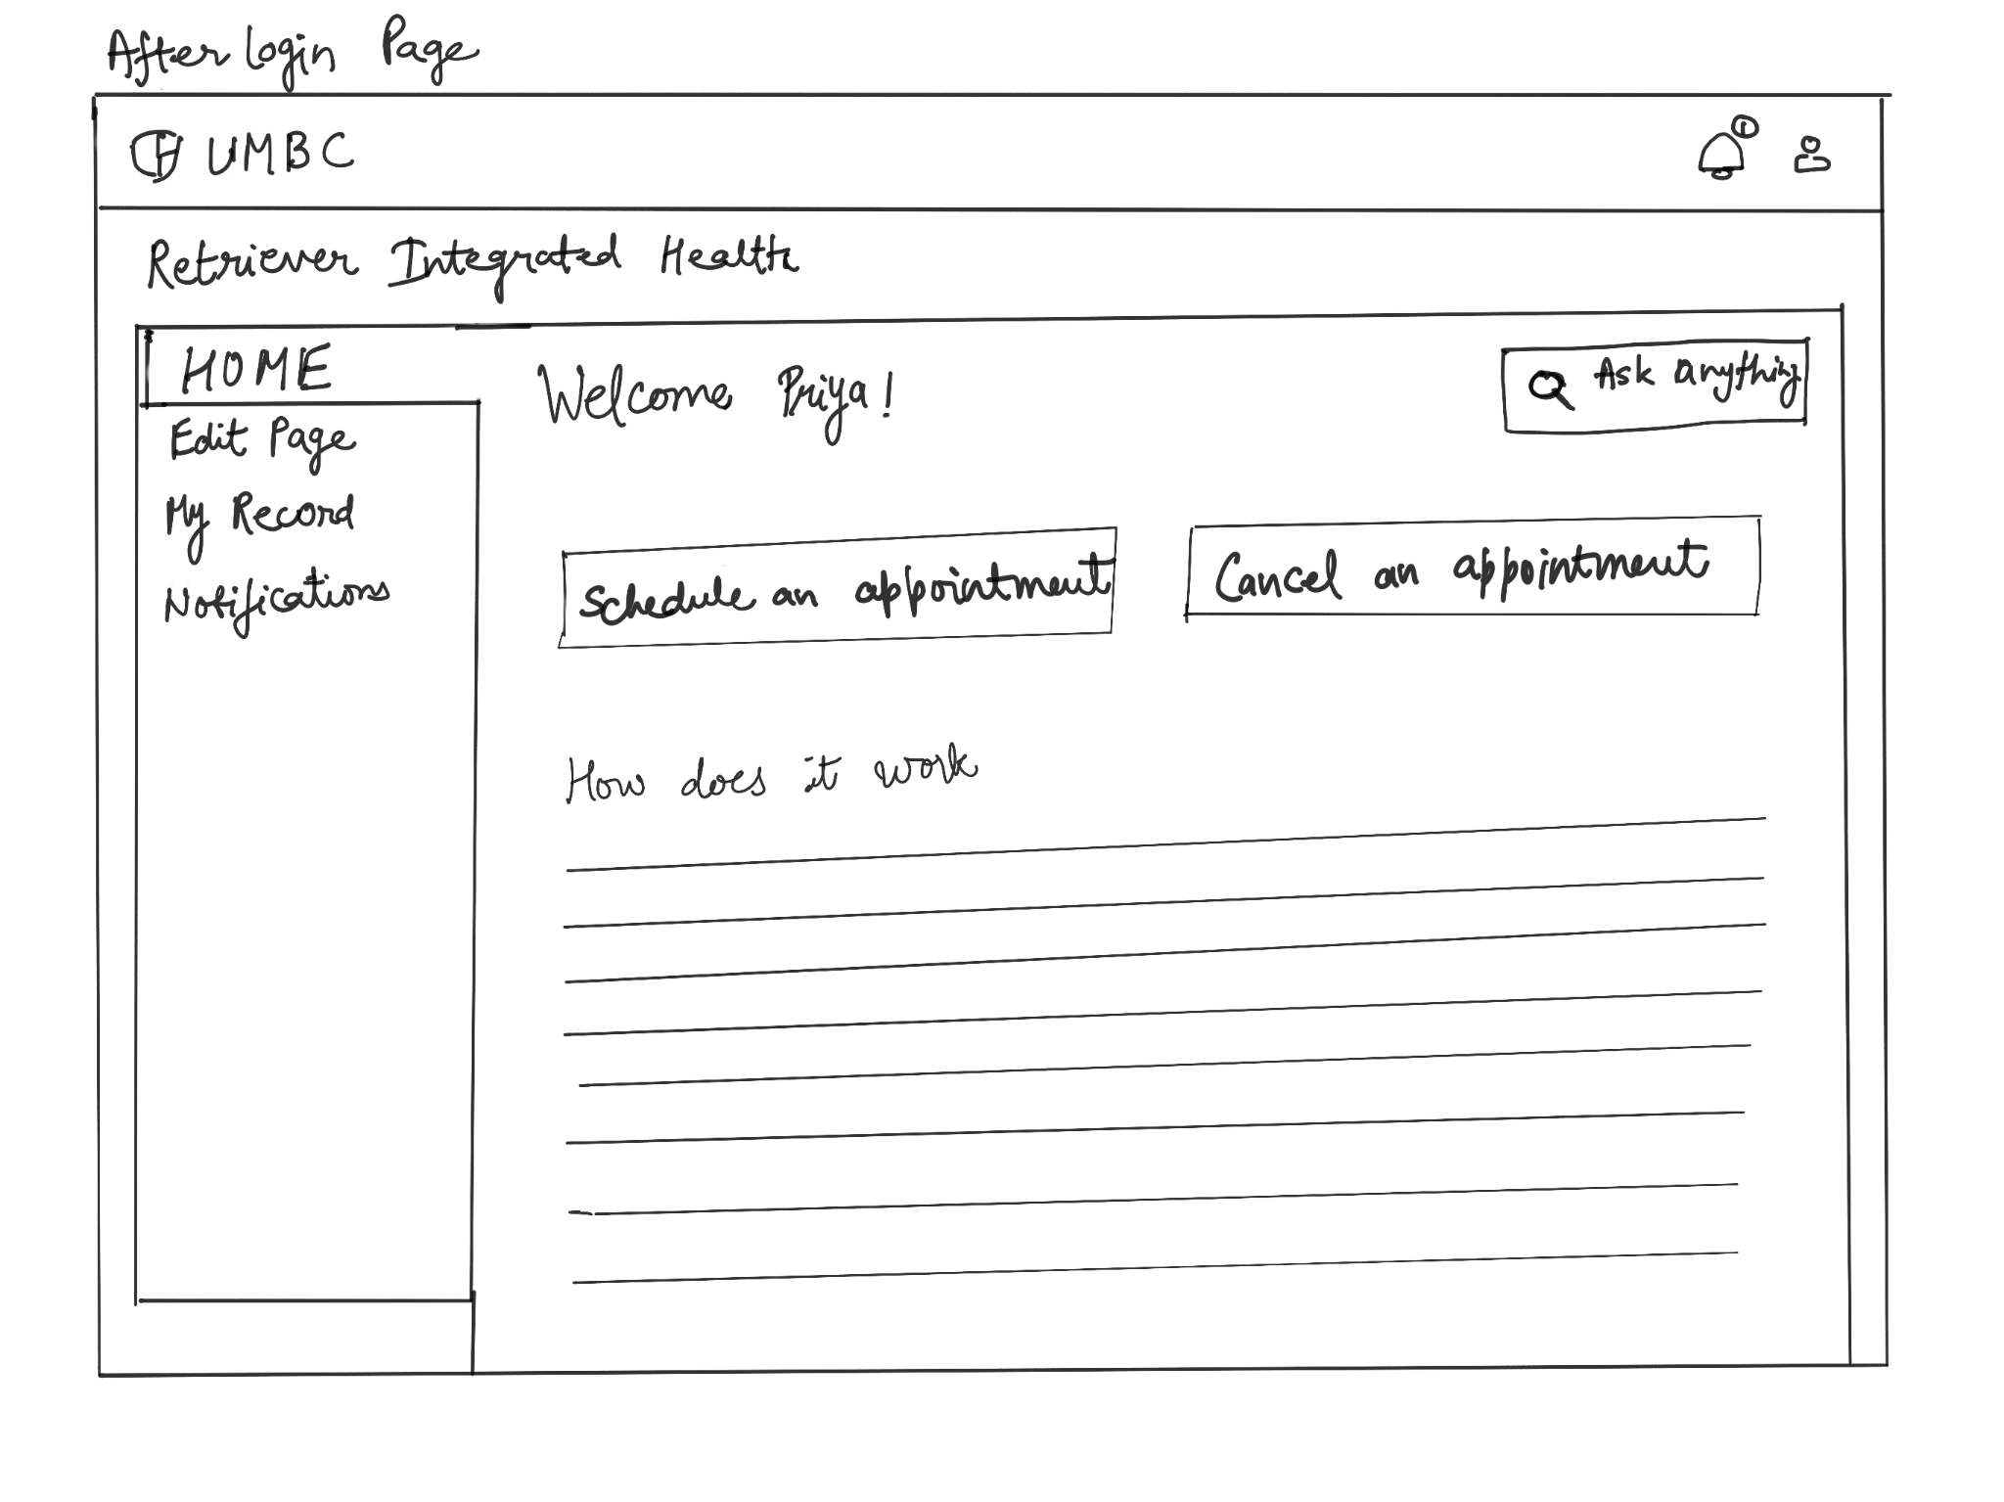

*Figure 28. Wireframe3: After Login Page*

The main difference between the system's current user interface and the one we've proposed is that the current landing page lacks a scheduling button. This causes confusion for users when they use the system for the first time and wastes their time as they look for the option to make an appointment. To address this problem, we thought it was crucial and practical to include a schedule button on the home page, as shown in the figures below. In addition, we suggested adding a cancel option to the screen on the user's profile page upon login. *Figure. After Login Page UI* illustrates the same in the following user interfaces.

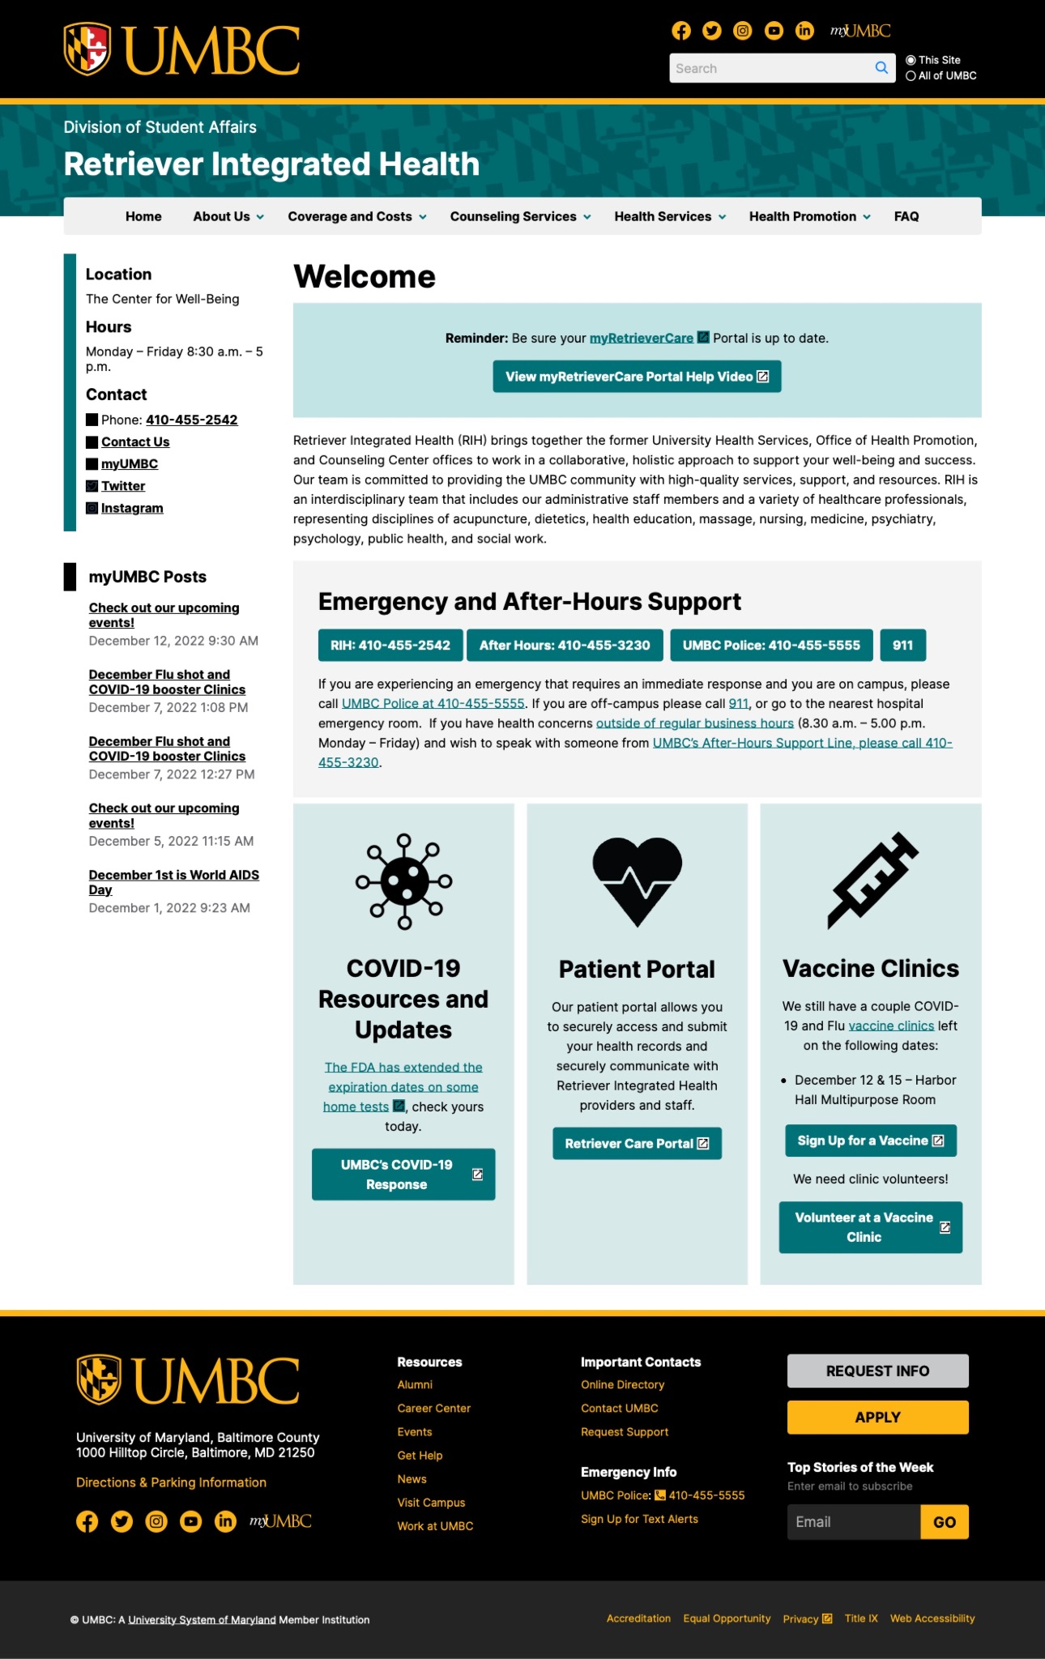

*Figure 29. Current Landing Page UI*

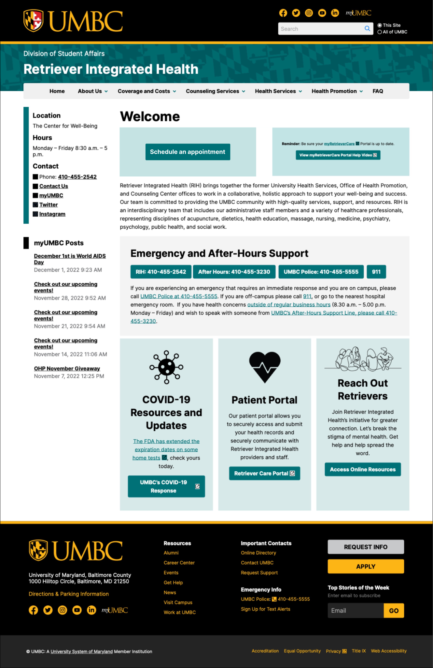

*Figure 30. Redesign Landing Page UI*

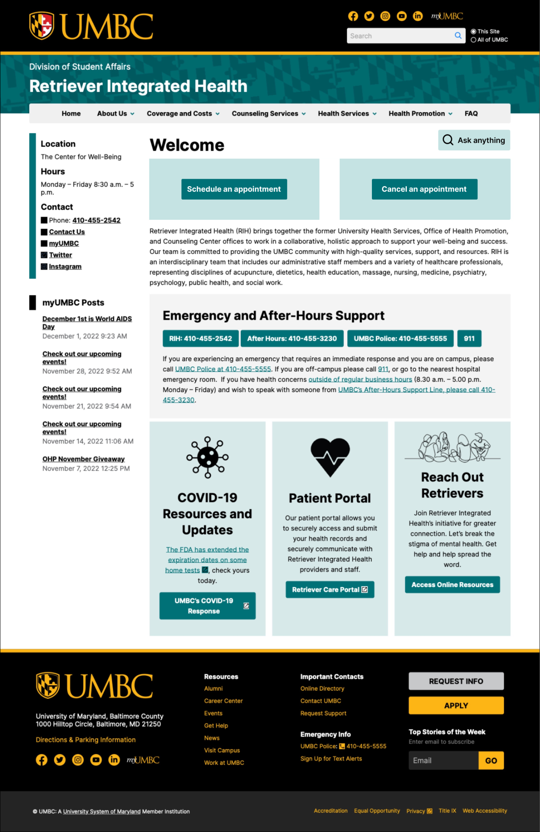

*Figure 31. After Login Page UI*

## 6.5 System acquisition

The system was entirely built by our own team as part of the product's internal development. So, in order to gain the UMBC Counseling system, we used custom development. The system was chosen because it would provide exactly what was needed, wouldn't have any defects, would allow the team to be flexible and creative, and would allow for the introduction of new solutions.

# Alternatives

The alternative to UMBC Counseling Center is that the center can use a third party application for scheduling an appointment for the students. The pros and cons of the same are mentioned below:

**Pros**:

* Users get a system to use quickly.
* Cost effective.
* Data is secure.
* Users can identify additional needs for later versions based on real experiences with the current version.

**Cons:**

* Complex Vendor Networks.
* Not secure (Data leakage).
* Lengthy development periods.

# Future work

As per the discussions in the above section, our proposed system for scheduling an appointment in the Retriever Integrated health services provided by UMBC has given solutions to the existing system problems such as - Limited availability of resources, Prolonged procedure to make an appointment, less customer satisfaction, etc.

The intention to propose this design was to make it easier for students to make a counseling appointment on their own by a self-serving scheduling application. A few of the points that can be implemented in the proposed system in the future are -

1. The proposed system is right now limited to the UMBC Server but could also be used further when designed properly for external use.
2. The Counselor details provided in the database of the application are the counselors who work for UMBC. This could also be extended by adding off-Campuses Counselors.
3. One of the limitations to use this application outside of the campus is that the User authentication would require some other kind of authentication except for Campus ID and school email ID.

The future work explained above is extended but not limited to the mentioned point.

# Conclusions

Our project’s main aim is to reduce the complexes faced by students in making an appointment at UMBC Counseling Services and also to make sure that each student gets the correct treatment, flexibility in consulting hours. This project is limited to UMBC College. We all hope that there is a chance for our project to be expanded in the near future. It is intended to help students as well as the Counseling Centre by developing a flexibility between them in the application we are creating. The maximum estimated cost for the project including all the development, design and software expenses is $60000. Lots of paperwork is cut down which minimizes the errors in patients history. This project has gained lots of positive responses, and also the major thing to mention is that we have some sort of support from the present UMBC Counseling Centre. Therefore, this project concludes to helping students with mental illness, Time saving, Minimization of errors and increase in proper employment of the staff.

# References

Baker, Sara A. *Analysis of the FY 2023 Maryland Executive Budget, 2022.* Department of Legislative Services Office of Policy Analysis . Retrieved 4 October 2022, from <https://mgaleg.maryland.gov/pubs/budgetfiscal/2023fy-budget-docs-operating-R30B31-University-of-Maryland-Baltimore-County.pdf>.

Gorman, K. S., Bruns, C., Chin, C., Fitzpatrick, N. Y., Koenig, L., LeViness, P., & Sokolowski, K. (n.d.). *Annual Report - AUCCCD*. Annual Survey: 2020. Retrieved December 13, 2022, from <https://www.aucccd.org/assets/documents/Survey/2019-2020%20Annual%20Report%20FINAL%20March-2021.pdf>

UMBC. (n.d.). *Counseling*. Retriever Integrated Health. Retrieved December 12, 2022, from <https://health.umbc.edu/counseling-services/counseling/>

UMBC. (n.d.). *Staff*. Retriever Integrated Health. Retrieved December 12, 2022, from <https://health.umbc.edu/about-us/staff/>

Van De Motter, A., & Allen, A. (2021, April 23). *Maryland College students seek mental health help amid covid-19 pandemic*. Maryland Matters. Retrieved October 4, 2022, from <https://www.marylandmatters.org/2021/04/23/maryland-college-students-seek-mental-health-help-amid-covid-19-pandemic/>